Q1.Which is a scalar quantity?

 | A | momentum
 | B | weight
 | C | power
 | D | moment

(Total 1 mark)
Q2.Which of the following is a scalar quantity?

 | A | velocity
 | B | kinetic energy
 | C | force
 | D | acceleration

(Total 1 mark)
Q3.Two forces of 6 N and 10 N act at a point. Which of the following could not be the magnitude of the result?

 | A | 16 N
 | B | 8 N
 | C | 5 N
 | D | 3 N

(Total 1 mark)
Q4. Figure 1 shows a parascender being towed at a constant velocity.
Figure 1
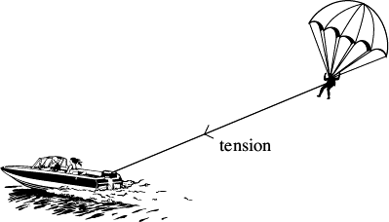
The forces acting on the parascender are shown in the free-body diagram in Figure 2.
Figure 2
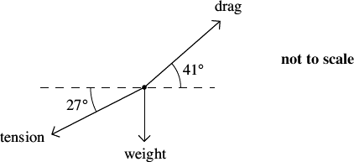
The rope towing the parascender makes an angle of 27° with the horizontal and has a tension of 2.2 kN. The drag force of 2.6 kN acts at an angle of 41° to the horizontal. Calculate the weight of the parascender.

weight ............................................... N
(Total 3 marks)
Q5. The figure below shows a stationary gymnast suspended by his arms at the end of two ropes.
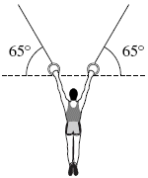
The tension in each rope is 4.1 × 10² N. The angle between each of the ropes and the horizontal is 65°.
Calculate the weight of the gymnast.
Give your answer to an appropriate number of significant figures.
...............................................................................................................................
...............................................................................................................................
...............................................................................................................................
...............................................................................................................................
weight of gymnast ...................................... N
(Total 3 marks)

