Q1.There is a supermassive black hole at the centre of the Milky Way galaxy. It is difficult to resolve images of the region around this black hole directly.
(a) (i) Sketch, on the axes, the variation in intensity of the diffraction pattern produced when light from a point object passes through a circular aperture.
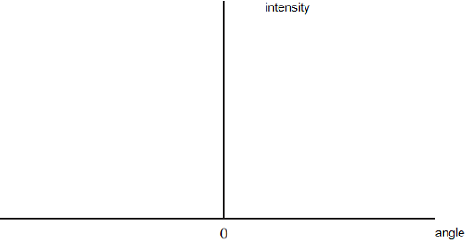
(2)
(ii) The Rayleigh criterion is used to determine the smallest angular separation between two point objects which can be resolved by a telescope. With reference to the diffraction patterns formed, explain what is meant by the Rayleigh criterion. You may draw a diagram to aid your explanation.
(2)
(b) Astronomers investigating the supermassive black hole at the centre of the Milky Way galaxy detect radio waves at a frequency of 230 GHz. By correlating the information from several radio telescopes, they can obtain images with the same resolution as a single radio telescope with a diameter of 5000 km. They calculate the radius of the black hole to be 1.2 × 10¹⁰m
(i) Calculate the minimum angular separation which could be resolved by a radio telescope of diameter 5000 km detecting waves of frequency 230 GHz.
(2)
(ii) The centre of the Milky Way galaxy is 25 000 light years from the Earth.
Show that the limit of the resolution of the telescope is approximately five times the angle subtended by the radius of the black hole at this distance.

(2)
(Total 8 marks)

Q2. (a) Draw the ray diagram for a Cassegrain telescope. Your diagram should show the paths of two rays, initially parallel to the principal axis, as far as the eyepiece.
(2)
(b) A telescope design very similar to the Cassegrain was first proposed by James Gregory in 1663. His telescope design was also the first to include a parabolic primary reflector.
(i) The use of a parabolic reflector overcomes the problem of spherical aberration. Draw a ray diagram to show how spherical aberration is caused by a concave spherical mirror.
(1)
(ii) The first telescope constructed to this design had a primary mirror of diameter 0.15 m. Calculate the minimum angular separation which could be resolved by this telescope when observing point sources of light of wavelength 630 nm. State an appropriate unit.
(2)
(iii) The astronomer Edmund Halley claimed to have used this telescope to observe the Cassini division, a dark band in the rings of Saturn. Calculate the angle subtended by the width of this band at the Earth, and comment on whether Halley’s claim is likely to be valid.
width of Cassini division = 4.8 × 10³km
distance from Earth to Saturn = 1.4 × 10⁹km
(2)
(Total 7 marks)

Q3. (a) Describe what is meant by an Airy disc and explain its significance in determining the resolving power of a telescope.
You may be awarded marks for the quality of written communication in your answer.
(3)
(b) The Arecibo telescope is the largest radio telescope in the world. It can be used to investigate distant galaxies by detecting the 1.4 GHz radio signal produced by molecular hydrogen.
(i) When the telescope was being built, any surface irregularities had to be less than 0.01 m in order for it to detect the molecular hydrogen signal. Verify this value using an appropriate calculation.
(ii) The diameter of the Arecibo telescope is 305 m. Calculate its resolving power when detecting the molecular hydrogen signal.
(3)
(c) Describe a problem associated with spherical reflecting telescopes and state how telescopes are designed to prevent it.
(2)
(Total 8 marks)
M1.(a) (i) central maximum at least twice the height of adjacent maxima
Allow graph to be above angle axis
Subsequent narrower maxima
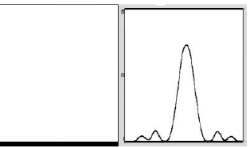
Any further maxima should not get bigger.
2

(ii) Two sources will be ( just) resolved if the central maximum of the diffraction pattern of one coincides
Central max and first min may be labelled on diagram in ai
with the first minimum of the other.
If they use the term 1st maximum it must be clear that it is the central maximum
Second mark is for correct part of the second diffraction pattern.
Clearly labelled diagram can get both marks.
2

(b) Use of Rs = 2GM/c²
Allow ce for one from:
missing out million; missing out mass of Sun; square in equation, but no square of speed of light in calculation
to give Rs = 2 × 6.67 × 10⁻¹¹ × 4.1 × 10⁶ × 2 × 10³⁰ / (3 × 10⁸)²
= 1.2 × 10¹⁰m
2sf
Sf mark stands alone but must be a number (not just stated 2 sf)
3

(c) (i) use of θ = λ/D
The first mark is for calculating the wavelength
to give θ = (3 × 10⁸ / 230 × 10⁹) / 5000 × 10³
= 2.6 × 10⁻¹⁰ (rad)
The second mark is for the use of the equation to give the final answer
Allow c.e. for an a.e. in the first mark.
If frequency used treat as p.e. – no marks
2

(ii) use of s = rθ
First mark is for the angle subtended (5.12 × 10⁻¹¹)
to give θ = 5 × 1.2 × 10¹⁰ / (25 000 × 9.46 × 10¹⁵)
= 2.5 × 10⁻¹⁰ (rad)
Second mark is for showing that this is 5 × answer to c(i).
which is (approximately) the answer to ci
Alternatives:
Calculate size of object that could just be resolved at this distance, and showing that this is 5 × radius of black hole.
2
[11]

M2. (a)
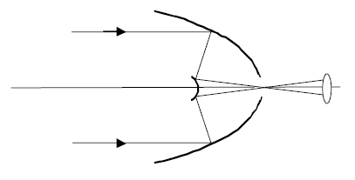
mirrors correct – concave primary and convex secondary
both rays correct to eyepiece
2

(b) (i)
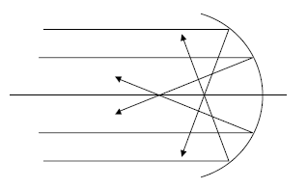
diagram to show two pairs of parallel rays being brought to
a focus, those further from the axis being focused closer
to the mirror
1

(ii) (use of θ = /λ/D)
to give θ = 630 × 10^{–9}/0.15 = 4.2 × 10^{–6}
rad
2

(iii) use of s = rθ
to give θ = 4.8 × 10³/1.4 × 10⁹ = 3.43 × 10^{–6}
(rad)
claim unlikely to be valid as this angle is smaller than
the minimum angular separation calculated in (ii)
2
[7]

M3. (a) the central bright spot (1)
of the diffraction pattern produced when light passes through a circular
aperture (1)
the minimum distance between two sources which can be resolved by a
telescope found when centre of one Airy disc falls just outside the Airy disc
for the other source (1)
[or statement referring to maxima and minima]
3
QWC 1

(b) (i) λ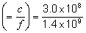= 0.21(4) m (1)
precision needed = λ/20 ≈ 0.01 m (1)
(ii) θ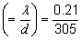= 6.9 × 10^{–4} rad (1) (6.88 × 10^{–4} rad)
(use of λ = 0.214 gives θ = 7.02 × 10^{–4} rad)
3

(c) parallel rays furthest from axis of reflector brought to focus closer to
reflector than rays close to axis (1) (allow correct diagram)
use parabolic reflector (1)
2
[8]

E1.The single slit diffraction pattern required for part (a) (i) was drawn satisfactorily by the majority of students, although there was some carelessness. Students should be encouraged to take more care with diagrams of this kind to show that the central maximum is twice as wide as the subsequent maxima, and that the height of the central maximum is significantly higher, and that the height decreases for each maximum.
Part (a) (ii) proved to be a little more challenging. There was some confusion related to how much overlap was appropriate. The best answers included a clear diagram showing two overlapping diffraction patterns with the central maximum of one pattern coinciding with the first minimum of the other. Students who did not include a diagram generally had difficulties describing the situation fully.
The formula in Part (b) has been tested many times before. Unfortunately a significant number of students lost marks by missing out the mass of the Sun, or failing to square the speed of light. This question also carried the significant figure mark. Students should be reminded that the answer should have the same number of significant figures as the poorest piece of data in the question.
Part (c) (i) was answered correctly by the majority of students. The calculation of the wavelength proved difficult for some students, however. A common error was simply using 1 / frequency or even using the frequency itself. The latter was treated as a physics error and gained no marks.
The comparison in part (c) (ii) again proved to be quite challenging. Some students found it difficult to convert the distances involved into a common unit. Many students made no attempt to refer to the answer to (c) (i).

E2. To get both marks in part (a) candidates were required to draw the curvature of both mirrors correctly and to show the path of two rays. Although it was answered correctly by many candidates, it was common to see a plane or concave mirror for the secondary, and rays leaving the secondary parallel.
Some of the better answers showed the two rays crossing at the gap in the primary mirror. In some answers, the curvature of the secondary mirror was unclear. It would be helpful if centres encouraged the correct convection when drawing mirrors – ie that the non-reflecting surface of the mirror should be hashed.
There was only one mark for (b)(i), and to be awarded this mark, candidates had to not only show that the focal points were different for parallel rays at different distances from the axis, but also get the foci the correct way round, ie the further out rays being focused closer to the mirror. Rather than simply showing the reflection in a concave mirror, some candidates repeated their ray diagram from part (a) and tried to show what happened to two pairs of rays. This unclear diagram rarely gained credit.

The calculation in part (b)(ii) was answered well by the majority of candidates. Giving the correct unit proved to be more of a problem, and it was fairly common to see correct numerical answers with the degree as the unit. The use of the phrase ‘minimum angular separation’ rather than ‘resolving power’ possibly made the question more accessible, but despite that, occasionally the watt was given as the unit.
The calculation in (b)(iii) proved to be slightly harder despite the fact that unit errors were ignored. Many candidates correctly noticed that the resolving power of the telescope would not be good enough to resolve the Cassini division with this telescope. Some candidates missed the point of the question and tried to argue that there would be a telescope good enough. Answers correctly arguing that the resolving power would be better with shorter wavelengths were rarely seen. Worryingly, this question was left blank by several candidates.

E3. This question was answered poorly on the whole, with many answers showing a lack of knowledge or understanding in all three areas the question covered. In part (a), very few candidates knew that the Airy disc is the bright central maximum of the diffraction pattern produced when light passes through a circular aperture. Several candidates thought that it was part of the telescope itself. Many thought it was the whole pattern, or failed to mention that it was due to diffraction. Its role in determining the resolving power was often described poorly, with many vague and ambiguous answers given. Some candidates obtained credit by drawing a relevant labelled diagram to help the explanation. This practice should be encouraged.
In part (b), most candidates knew of the need to calculate the wavelength and divide it by 20 to obtain a value for the upper limit of surface irregularities. Benefit of the doubt was given to candidates who performed the calculations but failed to state the significance of the answer obtained. In questions like this, candidates should be encouraged to finish off answers by stating how their calculations are related to the required information. The straightforward calculation in part (ii) was performed by most candidates, but several lost marks due to the usual unit errors associated with resolving power. Commonly, the unit was missed altogether or the degree or even the watt was suggested.
Simply writing ‘spherical aberration’ in part (c) was insufficient to gain the allocated mark. A clear description or diagram was required, showing how paraxial rays further from the principal axis are brought to a focus closer to the lens than those nearer the axis. Most candidates knew that the use of a parabolic mirror solved the problem. Many candidates confused chromatic and spherical aberration or wrote answers which were too vague to gain credit.

