Q1. (a) Bellatrix and Betelgeuse are stars in the constellation of Orion. Some of their properties aresummarised below.

 | Bellatrix | Betelgeuse
absolute magnitude | –6.0 | –2.7
apparent magnitude | 0.4 | 1.6
black-body temperature / K | 22 000 | 2 400

(i) Explain what is meant by absolute magnitude.
(1)

(ii) Which of the two stars is closer to the Earth? Explain your answer.
(1)

(b) (i) Calculate the wavelength of the peak intensity in the black-body radiation curve of Bellatrix.
answer = ...................................... m
(2)

(ii) Sketch the black-body radiation curve for Bellatrix. Label the wavelength axis with a suitable scale.
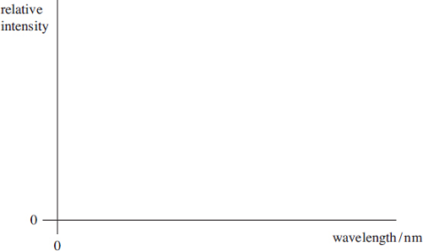
(3)
(Total 10 marks)
Q2. Sirius is a binary system consisting of two stars, Sirius A and Sirius B, the properties of which are summarised below.

 | Sirius A | Sirius B
absolute magnitude | 1.4 | 11.2
apparent magnitude | –1.4 | 8.4
diameter / 10³ km | 2400 | 12
black-body temperature/K | 10 000 | 25 000

(a) Calculate the distance to Sirius, giving an appropriate unit.
distance = .....................................
(3)

(b) (i) Calculate the ratio
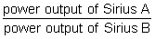
ratio = .....................................
(2)

(ii) Show that data in the table suggests that one star is about 8000 times brighter than the other.
(2)

(iii) With reference to the spectra of the two stars, explain why the value in part b (ii) is much greater than the answer to part b (i).
(3)
(Total 10 marks)

Q3. The diagram below shows the black body radiation curves for three stars, labelled P, Q and R.
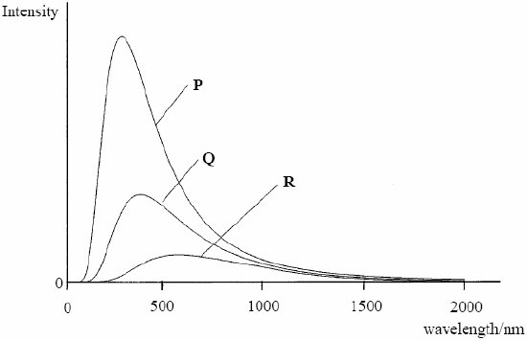
(a) (i) State and explain, without calculation, which one of these three stars is the hottest.
(ii) Calculate the black body temperature of the hottest star.
Temperature =.....................................
(3)

(Total 7 marks)
Q5. The Earth’s atmosphere absorbs electromagnetic radiation of certain wavelengths. Detectors on the surface of the Earth are largely restricted to the visible and radio regions.
(a) (i) On the axes below, draw the black body radiation curve for the Sun.

(ii) Mark on the wavelength axis the region affected by the atmosphere’s absorption of ultra violet radiation.
(iii) What is responsible for this absorption?
(iv) What effect can this absorption have on the measured temperature of a star? Explain your answer.
(4)

(b) The atmosphere has little effect on radio waves between 30 MHz and 300 GHz. This radio window was first exploited in 1946 when a short pulse of radio waves of wavelength 2.7 m was transmitted from the Earth and reflected back by the Moon.
(i) Show that the frequency of the transmitted waves falls within the radio window.

(Total 9 marks)

Q6. (a) The graph shows part of the visible region of the spectrum of the star Vega.
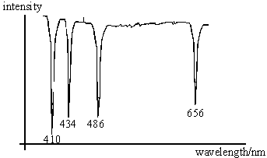

(b) (i) The wavelength at maximum intensity in the spectrum of Vega has a value of 300 nm. Show that this corresponds to a value of about 10 000 K for the surface temperature of Vega.
(ii) State the assumption made in your answer to (b)(i).
(2)

(Total 7 marks)

