Q1.(a) Define the term absolute magnitude.
(1)
(b) On the axes below draw the Hertzsprung-Russell (H-R) diagram, labelling the main sequence stars, giant stars and white dwarf stars. Complete the vertical axis by labelling a suitable absolute magnitude scale.
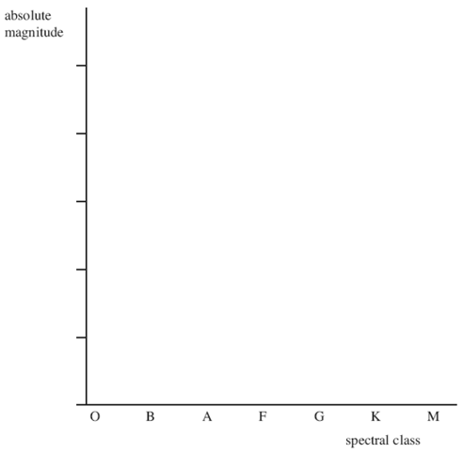
(3)

(c) Label a possible position of each of the following stars on the diagram above:
(i) the Sun
(1)
(ii) star W, which has the same intrinsic brightness as the Sun, but has a significantly higher temperature
(1)
(iii) star X, which has a similar spectrum to the Sun, but is significantly larger
(1)
(iv) star Y, which is significantly larger than the Sun and has prominent absorption lines of neutral atoms and titanium oxide (TiO) in its spectrum.
(1)
(d) How does the diameter of star W, in part (ii), compare with the diameter of the Sun? Explain your answer.
(3)

(e) Deneb is the brightest star in the constellation Cygnus.
(i) The black-body radiation curve for Deneb shows a peak at a wavelength
of 3.4 × 10^{–7} m. Calculate the black-body temperature of Deneb. Give your
answer to an appropriate number of significant figures.

answer = ........................................K
(3)

(ii) The power output of Deneb is 70000 times greater than the Sun. Calculate the radius of Deneb.
surface temperature of the Sun = 5700K

answer = .......................................m
(3)

(f) The spectrum of Deneb contains Hydrogen Balmer absorption lines. Describe how Hydrogen Balmer absorption lines are produced in the spectrum of a star.
The quality of your written communication will be assessed in this question.
(6)
(Total 23 marks)

