Q1. HT Cas is an eclipsing binary system in the constellation Cassiopeia. Figure 1 shows the variation in apparent magnitude (light curve) of the system over a period of time.
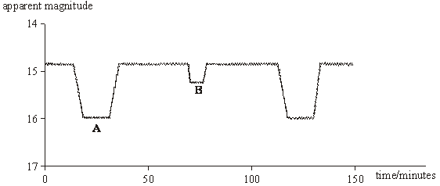
Figure 1

(a) Explain how the motion of the two stars produces the light curve in Figure 1.
Refer to regions A and B in your answer.
You may be awarded marks for the quality of written communication in your answer.
(4)

(b) Analysis of the spectra produced by the system shows that one of the stars is moving with an orbital speed of 400 km s^{–1}.
(i) The wavelength of a hydrogen line in the spectrum of this star has an average value of 656.28 nm. Calculate the maximum and minimum values of the wavelength of this line due to the star’s orbital motion.

(ii) Use Figure 1 to obtain a value of the period of the binary system, and calculate the radius of the orbit of this star.
(6)
(Total 10 marks)

M1. (a) two stars of different brightness orbit a common axis (1)
most of the time both stars are visible, so brightness is a maximum
i.e. low value of apparent magnitude (1)
at A, when dimmer star passes in front of brighter star there is an
increase in apparent magnitude (fall in brightness) (1)
at B, (half a cycle later), the brighter star passes in front of the dimmer,
brightness falls slightly hence small increase in apparent magnitude (1)
transit time indicate different sizes (1)
width of trough indicates transit times (1)
max 4
QWC 1

(b) (i) (use of Δλ = (–)λ gives) Δλ=656.28 × 10^{–9} 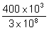 (1)
= 0.88 × 10^{–9}(m) (1) (0.875 × 10^{–9}(m))
maximum wavelength (= λ + Δλ) = 657.16 × 10^{–9} m and
minimum wavelength (= λ – Δλ) = 655.41 × 10^{–9}(m) (1)

(ii) time period = 110 × 60 =6600 s (1)
2πr = vt gives r =  (1)
= 4.2 × 10⁸m (1)
(allow C.E. for value of t)
6
[10]

E1. This question discriminated well but failure to gain one particular mark tended to restrict the number of candidates gaining the full 10 available marks. In the answer to part (a) the statement “the two stars orbit each other” was not given credit. It is more correct to state that they orbit a common centre of mass. Ambiguous statements were very common because candidates wrote about stars A and B, rather than the regions on the graph. Many able candidates also wrote incorrectly about the difference in brightness being due to stars getting significantly closer or further away, using their knowledge of the definitions of apparent and absolute magnitude to support their arguments. Answers referring solely to size, rather than the relative brightness of the two stars, also lost marks. To obtain full marks, candidates needed to state how the graph gave an idea of the orbital period or transit time.
The calculations in part (b) were generally done well, although there were plenty of opportunities to make mistakes. The most common mistake with the Doppler calculation occurred with the units and with powers of ten. In the second calculation many candidates simply calculated the circumference without then calculating the radius. It appeared that they simply multiplied a time by a speed, without understanding what the distance obtained was. The time period was also incorrectly measured by several candidates.

