Q1.It is said that Archimedes used huge levers to sink Roman ships invading the city of Syracuse. A possible system is shown in the following figure where a rope is hooked on to the front of the ship and the lever is pulled by several men.
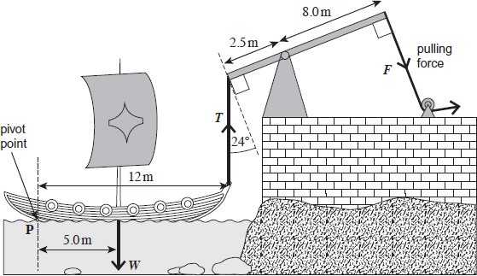
(a) (i) Calculate the mass of the ship if its weight was 3.4 × 10⁴ N.
(1)
(ii) Calculate the moment of the ship’s weight about point P. State an appropriate unit for your answer.
(2)
(iii) Calculate the minimum vertical force, T, required to start to raise the front of the ship.
Assume the ship pivots about point P.
(2)
(iv) Calculate the minimum force, F, that must be exerted to start to raise the front of the ship.
(3)
(Total 8 marks)
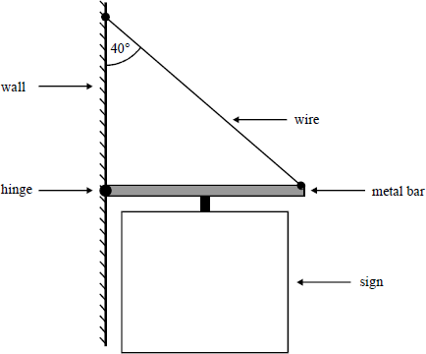
Q2. A public house sign is fixed to a vertical wall as shown in the diagram.
A uniform metal bar 0.75 m long is fixed to the wall by a hinged joint that allows free movement in the vertical plane only. The wire is fixed to the wall directly above the hinge and to the free end of the horizontal metal bar. The wire makes an angle of 40° with the wall.
A single support holds the sign and is mounted at the midpoint of the metal bar so that the weight of the sign acts through that point.
(a) (i) Copy the diagram and add three arrows showing the forces acting on the metal bar, given that the system is in equilibrium. Label the arrows A, B and C.
(ii) State the origin of the forces.
A
B
C
(5)
(b) The combined mass of the metal bar and sign is 12 kg and the mass of the wire is negligible. By taking moments about the hinged end of the bar, or otherwise, calculate the tension in the wire.
(4)
(Total 9 marks)

Q3.The figure below shows a simple ‘mobile’. This is a suspended ornament that moves in a slight breeze.
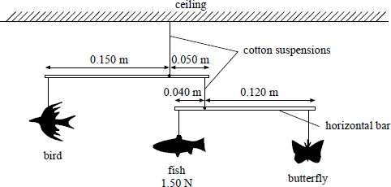
The weights of the objects are such that they are in equilibrium. The weights of the horizontal bars are negligible.
(a) State the principle of moments.
(2)
(b) The weight of the fish is 1.50 N.
Calculate the weight of:
(i) the butterfly;
(2)
(ii) the bird.
(2)
(c) The system is displaced so that the lower bar is no longer horizontal. Explain briefly whether this has any effect on the equilibrium of the system
(2)
(Total 8 marks)

