Q1.The velocity–time graph for a falling object is shown.
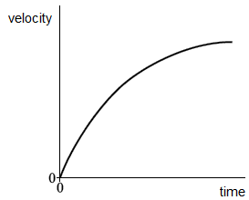
Which of the following shows the corresponding acceleration–time graph?
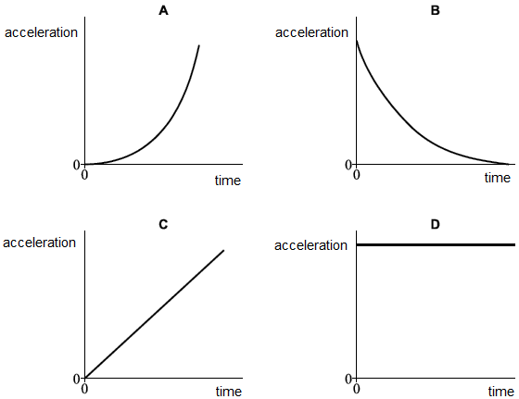

A
B
C
D

(Total 1 mark)
Q2.A roller coaster car is raised to a height of 65 m and released from rest.
What is the maximum possible speed of the car?

 | A | 11 m s⁻¹
 | B | 25 m s⁻¹
 | C | 36 m s⁻¹
 | D | 130 m s⁻¹

(Total 1 mark)

Q3.A ballbearing X of mass 2m is projected vertically upwards with speed u. A ballbearing Y of mass m is projected at 30° to the horizontal with speed 2u at the same time. Air resistance is negligible. Which of the following statements is correct?

 | A | The horizontal component of Y's velocity is u.
 | B | The maximum height reached by Y is half that reached by X
 | C | X and Y reach the ground at the same time.
 | D | X reaches the ground first.

(Total 1 mark)

Q4.Figure 1 shows the variation of velocity v with time t for a Formula 1 car during a test drive along a straight, horizontal track.
The total mass of the car and driver is 640 kg. The car engine provides a constant driving force of 5800 N.
Figure 1
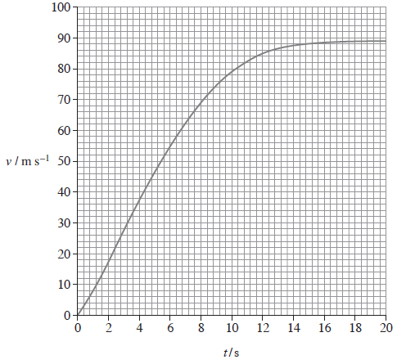
(a) (i) Determine the distance travelled by the car during the first 10 s.
distance ........................... m
(3)
(ii) Show that the instantaneous acceleration is about 4 m s⁻² when t is 10 s.
(2)

(iii) Calculate the magnitude of the resistive forces on the car when t is 10 s.
resistive forces ........................... N
(3)
(b) Figure 2 shows the aerofoil that is fitted to a Formula 1 car to increase its speed around corners.
Figure 2
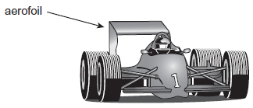
However, the aerofoil exerts an unwanted drag force on the car when it is travelling in a straight line so a Drag Reduction System (DRS) is fitted. This system enables the driver to change the angle of the aerofoil to reduce the drag.
The graph in Figure 1 is for a test drive along a straight, horizontal track. Under the conditions for this test drive, the DRS was not in use and the engine produced a constant driving force.
Explain why the velocity varies in the way shown in the graph.
Go on to explain how the graph will be different when the DRS is in use and the driving force is the same.
The quality of written communication will be assessed in your answer.
(6)
(Total 14 marks)

Q5.A snowboarder slides down a slope, as shown in the diagram below. Between B and C her acceleration is uniform.
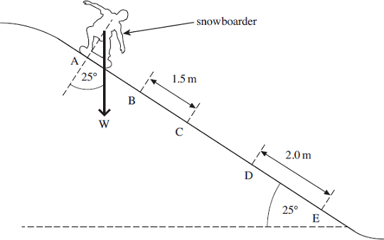
(a) The snowboarder travels 1.5 m from B to C in a time of 0.43 s and her velocity down the slope at C is 5.0 ms^{–1}.
Calculate her velocity down the slope at B.

velocity = ............................ ms^{–1}
(3)
(b) The combined mass of the snowboarder and snowboard is 75 kg and the angle of the slope is 25°
(i) Calculate the component of the weight of the snowboarder and snowboard acting down the slope.

weight component = ................................. N
(2)
(ii) At D the snowboarder has reached a constant velocity. She moves a distance of 2.0 m at constant velocity between D and E.
Calculate the work done against resistive forces as she moves from D to E.

work done = ................................... J
(1)
(c) State and explain what happens to the gravitational potential energy lost between D and E.
........................................................................................................................
........................................................................................................................
........................................................................................................................
........................................................................................................................
(3)
(Total 9 marks)
Q6. A sprinter is shown before a race, stationary in the ‘set’ position, as shown in the figure below. Force F is the resultant force on the sprinter’s finger tips. The reaction force, Y, on her forward foot is 180 N and her weight, W, is 520 N. X is the vertical reaction force on her back foot.
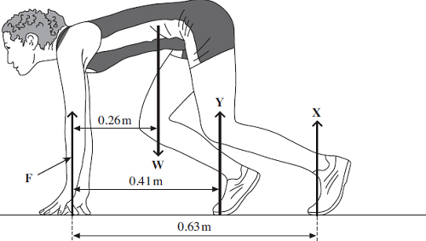
(a) (i) Calculate the moment of the sprinter’s weight, W, about her finger tips.
Give an appropriate unit.

answer = ..................................... unit .....................................
(2)
(ii) By taking moments about her finger tips, calculate the force on her back foot,marked X.

answer = ..................................N
(3)
(iii) Calculate the force F.

answer = ..................................N
(1)
(b) The sprinter starts running and reaches a horizontal velocity of 9.3 ms^{–1} in a distance
of 35 m.
(i) Calculate her average acceleration over this distance.

answer = .............................m s^{–2}
(2)
(Total 8 marks)

