Projectile Motion Exam Questions
Q1.The diagram below shows two different rifles being fired horizontally from a height of 1.5 m above ground level.
Assume the air resistance experienced by the bullets is negligible.
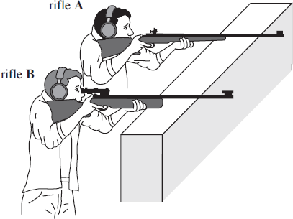
(a) When rifle A is fired, the bullet has a horizontal velocity of 430 m s⁻¹ as it leaves the rifle. Assume the ground is level.
(i) Calculate the time that the bullet is in the air before it hits the ground.
(2)
(ii) Calculate the horizontal distance travelled by the bullet before it hits the ground.
(1)

(b) Rifle B is fired and the bullet emerges with a smaller horizontal velocity than the bullet from rifle A.
Explain why the horizontal distance travelled by bullet B will be less than bullet A.
(3)
(Total 6 marks)

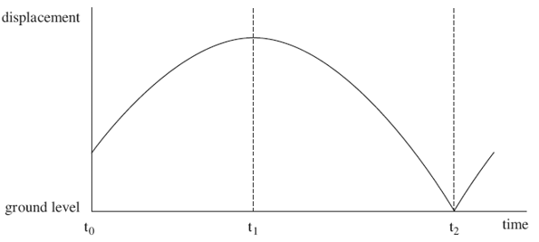
Q2. A boy throws a ball vertically upwards and lets it fall to the ground. Figure 1 shows how displacement relative to the ground varies with time for the ball.
Figure 1
(a) (i) State which feature of a displacement-time graph represents the velocity.
(1)

(ii) On the axes below, draw the shape of the velocity-time graph for the ball between t₀ and t₂. The starting point is labelled X.
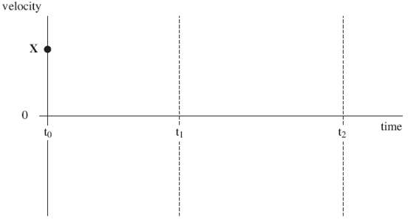
(3)

(Total 4 marks)

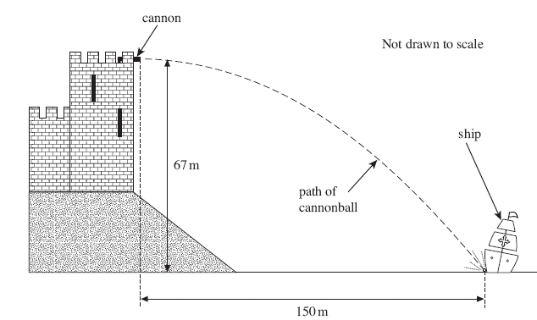
Q3. In a castle, overlooking a river, a cannon was once employed to fire at enemy ships.
One ship was hit by a cannonball at a horizontal distance of 150 m from the cannon as shown in the figure below. The height of the cannon above the river was 67 m and the cannonball was fired horizontally.
(a) (i) Show that the time taken for the cannonball to reach the water surface after being fired from the cannon was 3.7 s. Assume the air resistance was negligible.
(2)
(ii) Calculate the velocity at which the cannonball was fired. Give your answer to an appropriate number of significant figures.
(2)
(iii) Calculate the vertical component of velocity just before the cannonball hit the ship.
(2)
(iv) By calculation or scale drawing, find the magnitude and direction of the velocity of the cannonball just before it hit the ship.
(4)

Q4. While investigating projectile motion, a student used stroboscopic photography to determine the position of a steel ball at regular intervals as it fell under gravity. With the stroboscope flashing 20 times per second, the ball was released from rest at the top of an inclined track, and left the foot of the track at P, as shown in the diagram below.
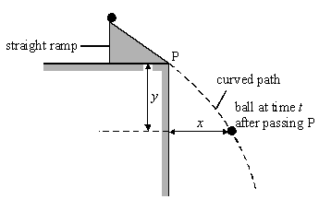
For each of the images on the photograph, the student calculated the horizontal distance, x, and the vertical distance, y, covered by the ball at time t after passing P. Both distances were measured from point P. He recorded his results for the distances x and y in the table.

image | x/cm | y/cm | t/s | (y/t)/cm s^{–1}
1 | 11.6 | 9.3 | 0.05
2 | 22.0 | 21.0 | 0.10
3 | 32.4 | 35.0 | 0.15
4 | 44.2 | 51.8 | 0.20
5 | 54.8 | 71.0 | 0.25
6 | 66.0 | 92.2 | 0.30

(a) Using two sets of measurements from the table, calculate the horizontal component of velocity of the ball. Give a reason for your choice of measurements.
(2)

(b) The student worked out that the variables y and t in the experiment could be represented by
$$\frac{y}{t}=u+kt$$
where u and k are constants.
(i) Complete the table above.
(ii) Use the data in the table to plot a suitable graph to confirm the equation.
(iii) Use your graph to find the values of u and k.
(9)
(c) State the physical significance of
u
k
(2)

(d) Calculate the magnitude of the velocity of the ball at point P.
(2)
(Total 15 marks)

