Q1.The nucleus of a radioactive isotope X is at rest and decays by emitting an α particle so that a new nuclide Y is formed.
Which one of the following statements about the decay is correct?
A The momentum of Y is equal and opposite to the momentum of the α particle.
B The momentum of Y is equal to the momentum of X.
C The kinetic energy of Y is equal to the kinetic energy of the α particle.
D The total kinetic energy is the same before and after the decay.
(Total 1 mark)
Q2.Trolley T₁, of mass 2.0 kg, collides on a horizontal surface with trolley T₂, which is also of mass 2.0 kg. The collision is elastic. Before the collision T₁ was moving at 4.0 m s^{–1} and T₂ was at rest.
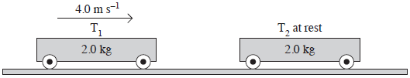
Which one of the following statements is correct?
Immediately after the collision
A T₁ is at rest and T₂ moves at 4.0 m s^{–1}.
B T₁ will rebound from T₂ at 4.0 m s^{–1}.
C T₁ and T₂ will both move at 2.8 m s^{–1}.
D T₁ and T₂ will both move at 1.4 m s^{–1}.
(Total 1 mark)
Q3.A firework rocket is fired vertically into the air and explodes at its highest point. What are the changes to the total kinetic energy of the rocket and the total momentum of the rocket as a result of the explosion?

 |  | total kinetic energy of  rocket | total momentum of  rocket
 | A | unchanged | unchanged
 | B | unchanged | increased
 | C | increased | unchanged
 | D | increased | increased

(Total 1 mark)

Q4.Which of the following is not a unit of power?

A | N m s^{–1}
B | kg m² s^{–3}
C | J s^{–1}
D | kg m^{–1} s^{–1}

(Total 1 mark)
Q5.The speed of an air rifle pellet is measured by firing it into a wooden block suspended from a rigid support.
The wooden block can swing freely at the end of a light inextensible string as shown in the figure below.
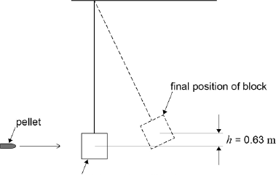
initial position of block
A pellet of mass 8.80 g strikes a stationary wooden block and is completely embedded in it. The centre of mass of the block rises by 0.63 m. The wooden block has a mass of 450 g.
(a) Determine the speed of the pellet when it strikes the wooden block.
(4)
(b) The wooden block is replaced by a steel block of the same mass.
The experiment is repeated with the steel block and an identical pellet. The pellet rebounds after striking the block.
Discuss how the height the steel block reaches compares with the height of 0.63 m reached by the wooden block. In your answer compare the energy and momentum changes that occur in the two experiments.
(4)
(c) Discuss which experiment is likely to give the more accurate value for the velocity of the pellet.
(2)
(Total 10 marks)

Q6. Deep space probes often carry modules which may be ejected from them by an explosion. A space probe of total mass 500 kg is travelling in a straight line through free space at 160 m s^{–1} when it ejects a capsule of mass 150 kg explosively, releasing energy. Immediately after the explosion the probe, now of mass 350 kg, continues to travel in the original straight line but travels at 240 m s^{–1}, as shown in the figure below.
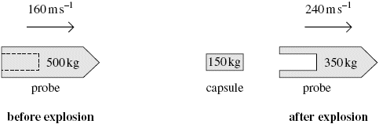
(a) Discuss how the principles of conservation of momentum and conservation of energy apply in this instance.
The quality of your written communication will be assessed in this question.
(6)
(b) (i) Calculate the magnitude of the velocity of the capsule immediately after the explosion and state its direction of movement.
(3)
(ii) Determine the total amount of energy given to the probe and capsule by the explosion.
(4)
(Total 13 marks)

