Q1. The circuit shown in the figure below shows an arrangement of resistors, W, X, Y, Z, connected to a battery of negligible internal resistance.
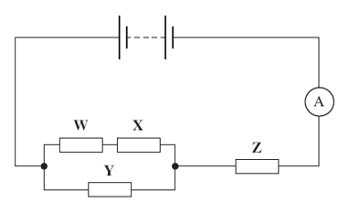
The emf of the battery is 10V and the reading on the ammeter is 2.0 A.
(a) (i) Calculate the total resistance of the circuit.

answer = ..................................... Ω
(1)
(ii) The resistors W, X, Y, and Z all have the same resistance. Show that your answer to part (a) (i) is consistent with the resistance of each resistor being 3.0 Ω.

answer = ..................................... Ω
(3)
(b) (i) Calculate the current through resistor Y.

answer = ...................................... A
(2)

(ii) Calculate the pd across resistor W.

answer = ...................................... V
(2)
(Total 8 marks)
Q2. The circuit shown below shows a thermistor connected in a circuit with two resistors, an ammeter and a battery of emf 15V and negligible internal resistance.
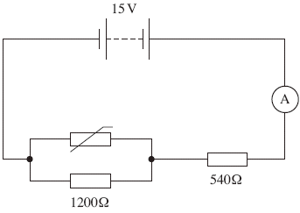
(a) When the thermistor is at a certain temperature the current through the ammeter is 10.0 mA.
(i) Calculate the pd across the 540 Ω resistor.

answer = ..................................... V
(1)

(ii) Calculate the pd across the 1200 Ω resistor.

answer = ..................................... V
(1)
(iii) Calculate the resistance of the parallel combination of the resistor and the thermistor.

answer = ..................................... Ω
(2)

(iv) Calculate the resistance of the thermistor.

answer = ..................................... Ω
(2)
(b) The temperature of the thermistor is increased so that its resistance decreases.
State and explain what happens to the pd across the 1200 Ω resistor.
......................................................................................................................
......................................................................................................................
......................................................................................................................
......................................................................................................................
(3)
(Total 9 marks)

Q3. The circuit in the diagram below contains four identical new cells, A, B, C and D, each of emf 1.5V and negligible internal resistance.
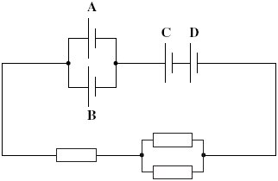
(a) The resistance of each resistor is 4.0 Ω.
(i) Calculate the total resistance of the circuit.

answer = ...................................... Ω
(1)

(ii) Calculate the total emf of the combination of cells.

answer = ....................................... V
(1)

(iii) Calculate the current passing through cell A.

answer = ....................................... A
(2)

(iv) Calculate the charge passing through cell A in five minutes, stating an appropriate unit.

answer = ......................................
(2)

(b) Each of the cells can provide the same amount of electrical energy before going flat.
State and explain which two cells in this circuit you would expect to go flat first.
......................................................................................................................
......................................................................................................................
......................................................................................................................
......................................................................................................................
......................................................................................................................
......................................................................................................................
(3)
(Total 9 marks)

