Q1.A revolving mountain top restaurant turns slowly, completing a full rotation in 50 minutes. A man is sitting in the restaurant 15 m from the axis of rotation. What is the speed of the man relative to a stationary point outside the restaurant?
A 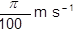
B 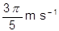
C 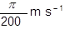
D 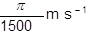
(Total 1 mark)
Q2. A particle of mass m moves in a circle of radius r at uniform speed, taking time T for each revolution. What is the kinetic energy of the particle?
A 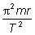
B 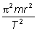
C 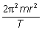
D 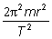
(Total 1 mark)
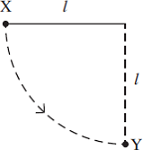
Q3. A ball of mass m, which is fixed to the end of a light string of length l, is released from rest at X.
It swings in a circular path, passing through the lowest point Y at speed v.
If the tension in the string at Y is T, which one of the following equations represents a correct application of Newton’s laws of motion to the ball at Y?
A 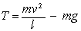 B 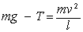
C 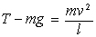 D 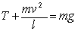
(Total 1 mark)

Q4. A young child of mass 20 kg stands at the centre of a uniform horizontal platform which rotates at a constant angular speed of 3.0 rad s^{–1}. The child begins to walk radially outwards towards the edge of the platform. The maximum frictional force between the child and the platform is 200 N. What is the maximum distance from the centre of the platform to which the child could walk without the risk of slipping?
A 1.1 m
B 1.3 m
C 1.5 m
D 1.7 m
(Total 1 mark)
Q5. A particle travels at a constant speed around a circle of radius r with centripetal acceleration a. What is the time taken for ten complete rotations?
A 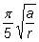
B 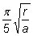
C 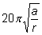
D 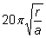
(Total 1 mark)

Q6. The Hubble space telescope was launched in 1990 into a circular orbit near to the Earth.
It travels around the Earth once every 97 minutes.
(a) Calculate the angular speed of the Hubble telescope, stating an appropriate unit.

answer = .....................................
(3)

(b) (i) Calculate the radius of the orbit of the Hubble telescope.

answer = ................................ m
(3)

(ii) The mass of the Hubble telescope is 1.1 × 10⁴ kg. Calculate the magnitude of the centripetal force that acts on it.

answer = ................................ N
(2)
(Total 8 marks)

Q9.The diagram below shows the orbits of two Earth satellites, a communications satellite in a geosynchronous orbit and a monitoring satellite in a low orbit that passes over the poles.
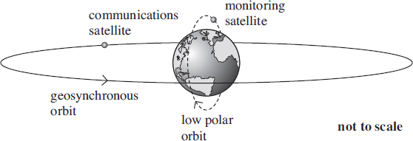
(a) The time period, T, of any satellite in a circular orbit around a planet is proportional to r^{3/2}, where r is the radius of its orbit measured from the centre of the planet. For a satellite in a low orbit that passes over the poles of the Earth, T is 105 minutes when r is 7370 km.
(i) Calculate the height above the surface of the Earth, in km, of a satellite in a geosynchronous circular orbit.
Give your answer to an appropriate number of significant figures.

height above surface .............................. km
(4)

(ii) Calculate the centripetal force acting on the polar orbiting satellite if its mass is
650 kg.

centripetal force ................................ N
(2)

(b) These geosynchronous and polar satellites have different applications because of their different orbits in relation to the rotation of the Earth.
Compare the principal features of the geosynchronous and polar orbits and explain the consequences for possible uses of satellites in these orbits.
In your answer you should explain why:
• a low polar orbit is suitable for a satellite used to monitor conditions on the Earth.
• a geosynchronous circular orbit above the Equator is especially suitable for a satellite used in communications.
The quality of your written communication will be assessed in your answer.
(6)
(Total 12 marks)

