Q1.A wave of frequency 5 Hz travels at 8 km s^{–1} through a medium. What is the phase difference, in radians, between two points 2 km apart?
A 0
B
C π
D
(Total 1 mark)

Q2. Which one of the following statements always applies to a damping force acting on a vibrating system?
A It is in the same direction as the acceleration.
B It is in the same direction as the displacement.
C It is in the opposite direction to the velocity.
D It is proportional to the displacement.
(Total 1 mark)

Q3. Which one of the following statements concerning forced vibrations and resonance is correct?
A An oscillating body that is not resonating will return to its natural frequency when the forcing vibration is removed.
B At resonance, the displacement of the oscillating body is 180° out of phase with the forcing vibration.
C A pendulum with a dense bob is more heavily damped than one with a less dense bob of the same size.
D Resonance can only occur in mechanical systems.
(Total 1 mark)

Q4. Which one of the following statements always applies to a damping force acting on a vibrating system?
A It is in the same direction as the acceleration.
B It is in the opposite direction to the velocity.
C It is in the same direction as the displacement.
D It is proportional to the displacement.
(Total 1 mark)

Q5.A periodic force is applied to a lightly-damped object causing the object to oscillate.
The graph shows how the amplitude A of the oscillations varies with the frequency f of the periodic force.
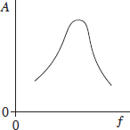
Which one of the following statements best describes how the shape of the curve would differ if the damping had been greater?
A the curve would be lower at all frequencies
B the curve would be higher at all frequencies
C the curve would be unchanged except at frequencies above the resonant frequency where it would be lower
D the curve would be unchanged except at frequencies above the resonant frequency where it would be higher
(Total 1 mark)

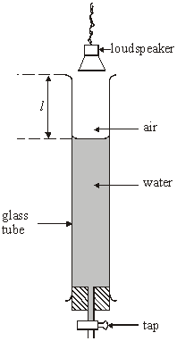
Q6. A small loudspeaker emitting sound of constant frequency is positioned a short distance above a long glass tube containing water. When water is allowed to run slowly out of the tube, the intensity of the sound heard increases whenever the length l (shown above) takes certain values.

(a) Explain these observations by reference to the physical principles involved.
You may be awarded marks for the quality of written communication in your answer.
..............................................................................
..........................................................................................
...........................................................................................
......................................................................................................................
......................................................................................................................
......................................................................................................................
......................................................................................................................
......................................................................................................................
......................................................................................................................
(4)
(b) With the loudspeaker emitting sound of frequency 480 Hz, the effect described in part (a) is noticed first when l = 168 mm. It next occurs when l = 523 mm.
Use both values of l to calculate
(i) the wavelength of the sound waves in the air column,
.............................................................................................................
.............................................................................................................
(ii) the speed of these sound waves.
.............................................................................................................
.............................................................................................................
(4)
(Total 8 marks)

Q7. An electric motor in a machine drives a rotating drum by means of a rubber belt attached to pulleys, one on the motor shaft and one on the drum shaft, as shown in the diagram below.
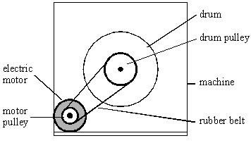
(a) The pulley on the motor shaft has a diameter of 24 mm. When the motor is turning at 50 revolutions per second, calculate
(i) the speed of the belt,
.............................................................................................................
.............................................................................................................
.............................................................................................................
(ii) the centripetal acceleration of the belt as it passes round the motor pulley.
.............................................................................................................
.............................................................................................................
.............................................................................................................
.............................................................................................................
(5)
(b) When the motor rotates at a particular speed, it causes a flexible metal panel in the machine to vibrate loudly. Explain why this happens.
......................................................................................................................
......................................................................................................................
......................................................................................................................
......................................................................................................................
(2)
(Total 7 marks)

