What is the resistance of this chain of resistors?

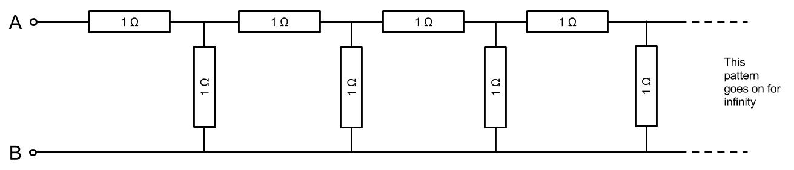

Can you work out the total resistance measured between points A and B?

There is a definite solution to this problem. To solve this you should try to simplify the problem, for instance, find the resistance of this:
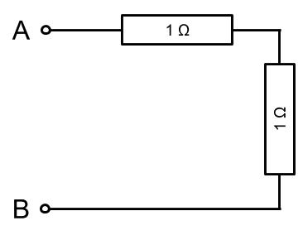
And then find the resistance as you add the next two resistors:
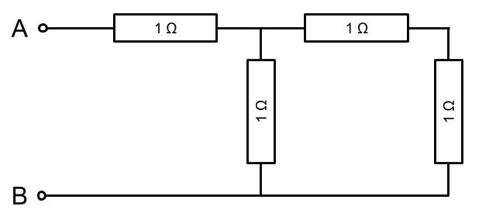
And so on. Do you notice any patterns? Can you use any mathematical techniques to help?

Another way to look at the problem could be to think about the first couple of resistors, and the infinite chain like this:
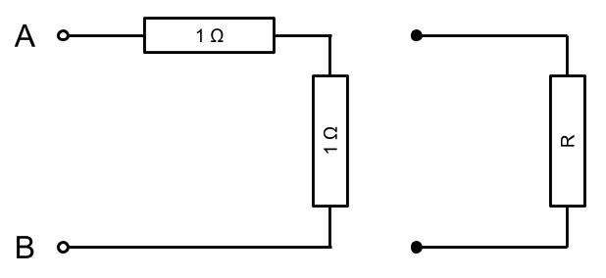
Can you solve this for R using the standard rules for parallel and series resistors?

