Q1.A fixed mass of gas occupies a volume V. The temperature of the gas increases so that the root mean square velocity of the gas molecules is doubled.
What will the new volume be if the pressure remains constant?

 | A
 | B
 | C | 2V
 | D | 4V

(Total 1 mark)
Q2.X and Y are two gas bottles that are connected by a tube that has negligible volume compared with the volume of each bottle.
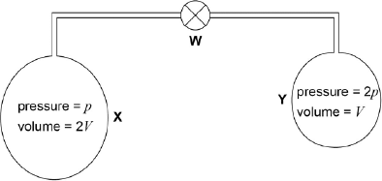
Initially the valve W is closed.
X has a volume 2V and contains hydrogen at a pressure of p.
Y has a volume V and contains hydrogen at a pressure of 2p.
X and Y are both initially at the same temperature.
W is now opened. Assuming that there is no change in temperature, what is the new gas pressure?

A
B
C
D

(Total 1 mark)

Q3.Which one of the following is not an assumption about the properties of particles in the simple kinetic theory?

 | A | <C²> is the average speed of the particles
 | B | The forces between the particles are negligible except when particles collide
 | C | The time spent by particles in collision is negligible compared with the time spent between collisions
 | D | The volume of the particles is negligible compared to the volume of the container

(Total 1 mark)

Q4.At a certain temperature, the root-mean-square speed of the molecules of a fixed volume of an ideal gas is c. The temperature of the gas is changed so that the pressure is halved. The root-mean-square speed of the molecules becomes
A
B
C
D 2c
(Total 1 mark)

Q5.The temperature of a room increases from 283K to 293K. The r.m.s. speed of the air molecules in the room increases by a factor of

 | A | 1.02
 | B | 1.04
 | C | 1.41
 | D | 2.00

(Total 1 mark)

Q6.

Figure 1 shows the cross-section of a bicycle pump with a cylindrical barrel. The piston has been pulled to the position marked X and the outlet of the pump sealed.
Figure 1
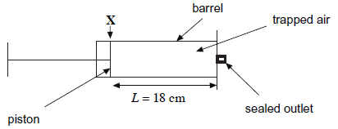
The length L of the column of trapped air is 18 cm and the volume of the gas is 1.7 × 10⁻⁴m³ when the piston is at position X. Under these conditions the trapped air is at a pressure p of 1.01 × 10⁵ Pa and its temperature is 19°C.
Assume the trapped air consists of identical molecules and behaves like an ideal gas in this question.
(a) (i) Calculate the internal diameter of the barrel.
diameter ____________________ m
(2)
(ii) Show that the number of air molecules in the column of trapped air is approximately 4 × 10²¹.
(3)
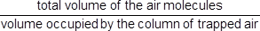
(iii) The ratio equals 7.0 × 10⁻⁴.
Calculate the volume of one air molecule.
volume ____________________ m³
(2)
(iv) The ratio in part (a)(iii) is important in supporting assumptions made in the kinetic theory of ideal gases.
Explain how the value of the ratio supports two of the assumptions made in the kinetic theory of ideal gases.

___________________________________________________________________
___________________________________________________________________
___________________________________________________________________
___________________________________________________________________
___________________________________________________________________
___________________________________________________________________
___________________________________________________________________
(3)
(b) The mass of each air molecule is 4.7 × 10⁻²⁶ kg.
Calculate the mean square speed of the molecules of trapped air when the length of the column of trapped air is 18.0 cm.
Give an appropriate unit for your answer.
mean square speed ____________________ unit __________
(4)
(c) The piston is pushed slowly inwards until the length L of the column of trapped air is 4.5 cm.
Figure 2 shows how the pressure p of the trapped air varies as L is changed during this process.
Figure 2
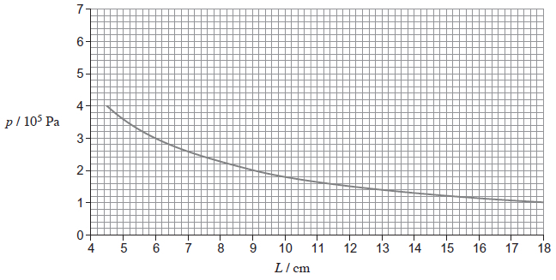
(i) Use data from Figure 2 to show that p is inversely proportional to L.

(3)
(ii) Name the physical property of the gas which must remain constant for p to be inversely proportional to L.
_________________________________________________________
(1)
(d) Explain how the relationship between p and L shown in Figure 2 can be predicted using the kinetic theory for an ideal gas.
___________________________________________________________________
___________________________________________________________________
___________________________________________________________________
___________________________________________________________________
___________________________________________________________________
___________________________________________________________________
___________________________________________________________________
___________________________________________________________________
(4)
(Total 22 marks)

Q7.Helium is a monatomic gas for which all the internal energy of the molecules may be considered to be translational kinetic energy.
molar mass of helium = 4.0 × 10^{–3} kg
the Boltzmann constant = 1.38 × 10^{–23} J K^{–1}
the Avogadro constant = 6.02 × 10²³ mol^{–1}
(a) Calculate the kinetic energy of a tennis ball of mass 60 g travelling at 50 m s^{–1}.
(1)
(b) Calculate the internal energy of 1.0 g of helium gas at a temperature of 48K.
(3)
(c) At what temperature would the internal energy of 1.0 g of helium gas be equal to the kinetic energy of the ball in part (a).
(1)
(Total 5 marks)

Q8. (a) (i) One of the assumptions of the kinetic theory of gases is that molecules make elastic collisions. State what is meant by an elastic collision.

______________________________________________________________

______________________________________________________________

(ii) State two more assumptions that are made in the kinetic theory of gases.

______________________________________________________________

______________________________________________________________

______________________________________________________________

______________________________________________________________
(3)

(b) One mole of hydrogen at a temperature of 420 K is mixed with one mole of oxygen at 320 K. After a short period of time the mixture is in thermal equilibrium.
(i) Explain what happens as the two gases approach and then reach thermal equilibrium.

______________________________________________________________

______________________________________________________________

______________________________________________________________

______________________________________________________________

(ii) Calculate the average kinetic energy of the hydrogen molecules before they are mixed with the oxygen molecules.

______________________________________________________________

______________________________________________________________

______________________________________________________________
(4)
(Total 7 marks)

