Q1.A Hertzsprung-Russell diagram for Main Sequence stars is shown below.
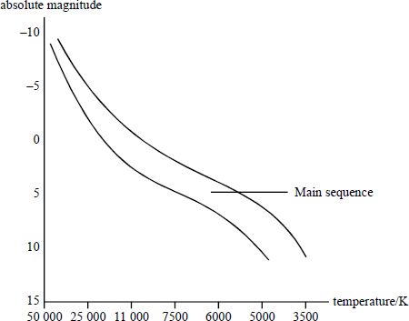

(a) (i) Label on the diagram the regions occupied by White Dwarfs and Red Giants.
(ii) Use the diagram to explain why Red Giant stars must be very much larger than White Dwarfs.
(4)
(b) (i) Mark the spectral classes O to M on the diagram.
(ii) Describe briefly the spectra of stars in class O, class A and class M.
class O
class A
class M
(6)
(Total 10 marks)

Q2.Antares is a red supergiant star in the constellation of Scorpio. It has a mass about 18 times that of the Sun.
Eventually the star will become a supernova, leaving behind a core that could form a neutron star or a black hole.
(a) State what is meant by a supernova.

(1)

(b) State the defining properties of a neutron star.

(2)

(c) To become a black hole it is likely that the core would have to have a mass at least twice that of the Sun.
Calculate the Schwarzschild radius of a black hole with a mass twice that of the Sun.

radius = ___________________ m
(2)

(d) Some scientists are concerned about the consequences for the Earth of a supernova occurring in a nearby part of the galaxy.
Explain the cause of this concern.
(2)
(Total 7 marks)

M1.(a) (i) correct Red Giants and White Dwarfs
(ii) Red Giants colder than White Dwarfs (1)
but Red Giants are brighter (1)
must have larger surface area (1)
4

(b) (i) correct OBAFGKM (1)
(ii) class O: strong He lines present (1)
H₂ lines present, but weak (1)
class A: H₂ lines at max strength (1)
ionised metals at max strength [or (neutral) metal lines begin to appear] (1)
class M: (neutral) metal lines strong (1)
molecular bands prominent (1)
max 6
[10]

M2.(a) An object that produces a rapid increase in brightness ✓
Allow lowering in value of absolute magnitude
1

(b) Extremely dense ✓
Ignore descriptions of Neutron star surface
1

Made up of neutrons ✓
Ignore refs to spinning or producing radio waves
1

(c) Use of Rs = 2GM / c²
To give
Rs = 2 x 6.67x 10⁻¹¹ x 2 x 2 x 10³⁰ / (3 x 10⁸)² ✓
First mark is for substitution
1

= 5.9 x 10³ m ✓
Second mark for answer
1

(d) Collapsing star can produce gamma ray bursts with energy similar to total output of Sun ✓
First mark is for gamma ray burst and an idea of the amount of energy
1

Highly collimated – if in direction of Earth, could cause mass extinction event ✓
Second mark is for consequence.
1
[7]

E1.Almost all candidates scored the mark awarded for the Hertzsprung-Russell diagram and most were able to argue correctly why Red Giant stars had a larger surface area than White Dwarfs, but in many cases the answers were flawed by referring to magnitude and not to brightness and also by concluding that the Red Giants must be ‘larger’ than White Dwarfs (information from the question) instead of stating that they must radiate over a larger surface area.

In part (b), apart from knowing the spectral classes of the stars, the question was, in general, poorly answered. Describing the spectrum in terms of lines present was fairly rare and candidates were reluctant to include more than one feature for each class. More often than not the question was misunderstood and general descriptions were given, which included the type of star in each class with details on their temperature, colour and what they were composed of.

