/37
Potential Dividers HW

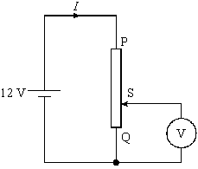
Q1. (a) In the circuit shown in Figure 1, the battery has an emf of 12 V and negligible internal resistance.
PQ is a potential divider, S being the position of the sliding contact. In the position shown, the resistance between P and S is 180 Ω and the resistance between S and Q is 60 Ω.

(i) Calculate the current, I, in the circuit, assuming that there is no current through the voltmeter V.
Figure
(ii) What property of the voltmeter allows us to assume that no current flows through it?
(iii) What is the reading on the voltmeter?
(4)

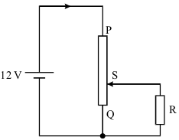
(b) The circuit in Figure 1 is modified as shown in Figure 2, by exchanging the voltmeter for a load R, whose resistance is about the same as the resistance of section SQ of the potential divider.

Explain, without calculation, why the current through the battery increases in value from that in part (a).
You may be awarded marks for the quality of written communication in your answer.
Figure
(2)
(Total 6 marks)

Q2. The graph shows how the resistance, R_{R}, of a metal resistor and the resistance, R_{Th}, of a thermistor change with temperature.
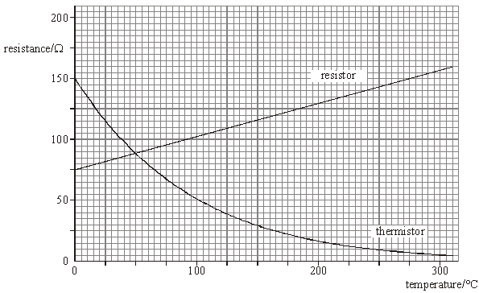
(a) Give the values of the resistance R_{R} and R_{Th} at a temperature of 200 °C.
(1)
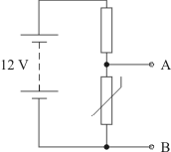
(b) The resistor and thermistor are connected in series to a 12V battery of negligible internal resistance, as shown in Figure 3.

(i) Calculate the voltage across the terminals AB when both the resistor and thermistor are at 200 °C.
(ii) Assuming that the temperature of the resistor always equals the temperature of the thermistor, deduce the temperature when the voltage across the resistor equals the voltage across the thermistor.
Figure
(4)
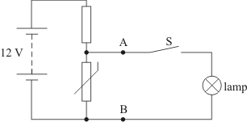
(c) A lamp and a switch are now connected across the terminals AB, as shown in Figure 4.
The temperature of the thermistor does not change from that obtained in part (b)(ii).
(i) The lamp is rated at 2.0 W at a voltage of 6.0 V. Calculate the resistance of the lamp at this rating.
(ii) The switch S is now closed. Explain, without calculation, why the voltage across the thermistor will fall from the value in part (b)(ii).
Figure
(4)
(Total 9 marks)

Q3. In the circuit shown in the figure below, the battery, of negligible internal resistance, is connected to two resistors which form a potential divider.
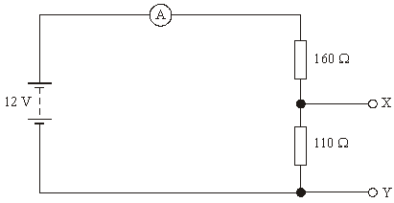
(a) (i) Calculate the current through the ammeter.
(ii) A 20 Ω resistor is now connected between X and Y. State and explain, without further calculation, whether the current through the ammeter will increase or decrease.
You may be awarded marks for the quality of written communication in your answer.
(4)

(b) The 20 Ω resistor is now removed and replaced with a voltmeter. Stating the assumption made, show that the reading on the voltmeter is 4.9 V.
(2)

(c) The voltmeter is now removed and the terminals X and Y joined together with a wire. Calculate the reading on the ammeter.
(2)
(Total 8 marks)

Q4. (a) A student wishes to investigate how the resistance of a thermistor changes with temperature.
(i) Draw a labelled diagram of a suitable circuit that would enable the student to measure the resistance of the thermistor.
(2)
(ii) Describe the procedure the student would follow in order to obtain accurate and reliable measurements of the resistance of the thermistor at different temperatures.
The quality of your written communication will be assessed in this question.
(6)

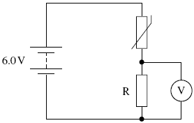
(b) The diagram in figure 5 shows a thermistor connected in series with a resistor, R, and battery of emf 6.0 V and negligible internal resistance.
When the temperature is 50 °C the resistance of the thermistor is 1.2 kΩ. The voltmeter connected across R reads 1.6V.
(i) Calculate the pd across the thermistor.
(1)
Figure
(ii) Calculate the current in the circuit.
(1)
(iii) Calculate the resistance of R quoting your answer to an appropriate number of significant figures.
(2)
(c) State and explain the effect on the voltmeter reading if the internal resistance of the battery in the circuit in part (b) was not negligible.
(2)
(Total 14 marks)

