Q1.The frequency of a body moving with simple harmonic motion is doubled. If the amplitude remains the same which of the following is also doubled?

 | A | The time period.
 | B | The total energy.
 | C | The maximum velocity.
 | D | The maximum acceleration.

(Total 1 mark)
Q2.A particle oscillates with undamped simple harmonic motion.
The acceleration of the particle

 | A | is always in the opposite direction to its velocity.
 | B | decreases as the potential energy increases.
 | C | is proportional to the frequency.
 | D | is least when the speed is greatest.

(Total 1 mark)
Q3.Which one of the following graphs shows how the acceleration, a, of a body moving with simple harmonic motion varies with its displacement, x?
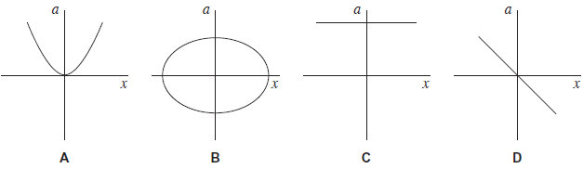
(Total 1 mark)
Q4.A particle of mass m oscillates in a straight line with simple harmonic motion of constant amplitude. The total energy of the particle is E. What is the total energy of another particle of mass 2m, oscillating with simple harmonic motion of the same amplitude but double the frequency?
A E
B 2E
C 4E
D 8E
(Total 1 mark)
Q5. The two diagrams in the figure below show a student before and after she makes a bungee jump from a high bridge above a river. One end of the bungee cord, which is of unstretched length 25 m, is fixed to the top of a railing on the bridge. The other end of the cord is attached to the waist of the student, whose mass is 58 kg. After she jumps, the bungee cord goes into tension at point P. She comes to rest momentarily at point R and then oscillates about point Q, which is a distance d below P.
BEFORE AFTER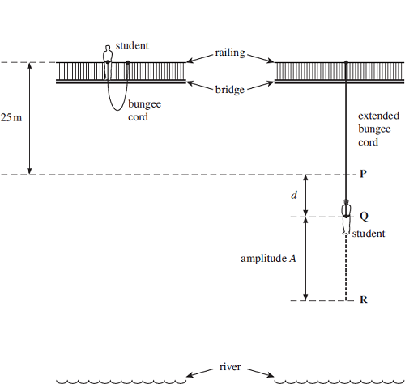
(a) (i) Assuming that the centre of mass of the student has fallen through a vertical distance of 25 m when she reaches point P, calculate her speed at P.
You may assume that air resistance is negligible.

answer = ........................... ms^{–1}
(2)

(ii) The bungee cord behaves like a spring of spring constant 54 Nm^{–1}.
Calculate the distance d, from P to Q, assuming the cord obeys Hooke’s law.

answer = ................................ m
(2)

(b) As the student moves below P, she begins to move with simple harmonic motion for part of an oscillation.
(i) If the arrangement can be assumed to act as a mass-spring system, calculate the time taken for one half of an oscillation.

answer = ................................ s
(2)
(ii) Use your answers from parts (a) and (b)(i) to show that the amplitude A, which is the distance from Q to R, is about 25 m.

(3)
(c) Explain why, when the student rises above point P, her motion is no longer simple harmonic.
........................................................................................................................
........................................................................................................................
........................................................................................................................
........................................................................................................................
........................................................................................................................
........................................................................................................................
........................................................................................................................
(2)
(d) (i) Where is the student when the stress in the bungee cord is a maximum?
...............................................................................................................
...............................................................................................................
(1)
(ii) The bungee cord has a significant mass. Whereabouts along the bungee cord is the stress a maximum? Explain your answer.
...............................................................................................................
...............................................................................................................
...............................................................................................................
...............................................................................................................
(2)
(Total 14 marks)
Q6. (a) A body is moving with simple harmonic motion. State two conditions that must be satisfied concerning the acceleration of the body.
condition 1 ....................................................................................................
......................................................................................................................
condition 2 …..........................……...............................................................
......................................................................................................................
(2)
(b) A mass is suspended from a vertical spring and the system is allowed to come to rest.
When the mass is now pulled down a distance of 76 mm and released, the time taken for 25 oscillations is 23 s.
Calculate
(i) the frequency of the oscillations,
.............................................................................................................
.............................................................................................................
(ii) the maximum acceleration of the mass,
.............................................................................................................
.............................................................................................................
(iii) the displacement of the mass from its rest position 0.60 s after being released.
State the direction of this displacement.
.............................................................................................................
.............................................................................................................
.............................................................................................................
.............................................................................................................
(6)
(c)
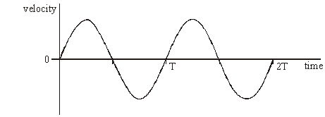
Figure 1
Figure 1 shows qualitatively how the velocity of the mass varies with time over the first two cycles after release.

(i) Using the axes in Figure 2, sketch a graph to show qualitatively how the displacement of the mass varies with time during the same time interval.
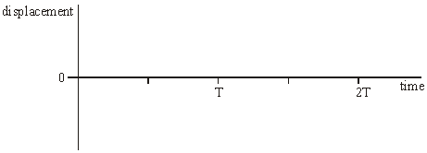
Figure 2

(ii) Using the axes in Figure 3, sketch a graph to show qualitatively how the potential energy of the mass-spring system varies with time during the same time interval.
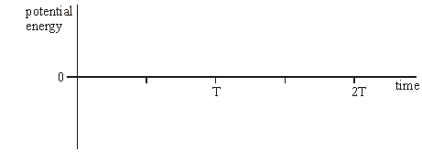
Figure 3
(4)
(Total 12 marks)
Q7.(a) Simple harmonic motion may be represented by the equation
a = – (2πf)²x
(i) Explain the significance of the minus sign in this equation.
...............................................................................................................
...............................................................................................................
(1)

(ii) In Figure 1 sketch the corresponding v-t graph to show how the phase of velocity v relates to that of the acceleration a.
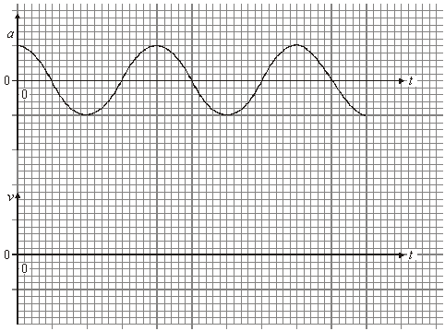
(1)
(b) (i) A mass of 24 kg is attached to the end of a spring of spring constant 60 N m^{–1}. The mass is displaced 0.035 m vertically from its equilibrium position and released. Show that the maximum kinetic energy of the mass is about 40 mJ.

(5)
(ii) When the mass on the spring is quite heavily damped its amplitude halves by the end of each complete cycle. On a sheet of graph paper sketch a graph to show how the kinetic energy, E_{k}, of the mass on the spring varies with time over a single period. Start at time, t = 0, with your maximum kinetic energy. You should include suitable values on each of your scales.

(3)
(Total 10 marks)

