Year 12 Resistivity HW Questions

1. The cable shown in the diagram is used to transmit electricity and is made from strands of steel wire and strands of aluminium wire. The strands of wire are in electrical contact with each other along the length of the cable.
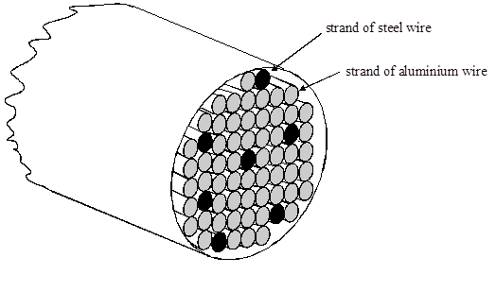
(a) Calculate the resistance of one strand of aluminium wire with a diameter of 3.2 mm and a length of 1.0km.
The resistivity of aluminium is 2.65x10⁻⁸ Ωm
(b) The resistance of one strand of steel wire in a 1.0 km length of cable is 19.9 Ω. Calculate the resistance of 1.0 km of the cable made up of seven strands of steel wire and fifty four strands of aluminium wire.
(Total 5 marks)

2. (a) The resistivity of a material in the form of a uniform resistance wire is to be measured. The area of cross-section of the wire is known.
The apparatus available includes a battery, a switch, a variable resistor, an ammeter and a voltmeter.
(i) Draw a circuit diagram using some or all of this apparatus, which would enable you to determine the resistivity of the material.

(ii) Describe how you would make the necessary measurements, ensuring that you have a range of values.

(iii) Show how a value of the resistivity is determined from your measurements.
(9)
(b) A sheet of carbon-reinforced plastic measuring 80 mm × 80 mm × 1.5 mm has its two large surfaces coated with highly conducting metal film. When a potential difference of 240V is applied between the metal films, there is a current of 2.0 mA in the plastic. Calculate the resistivity of the plastic.
(3)

(c) If four of the units described in part (b) are connected as shown in the diagram, calculate the total resistance of the combination.
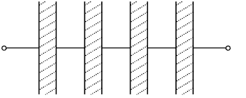
(2)
(Total 14 marks)

