Equilibrium of three forces
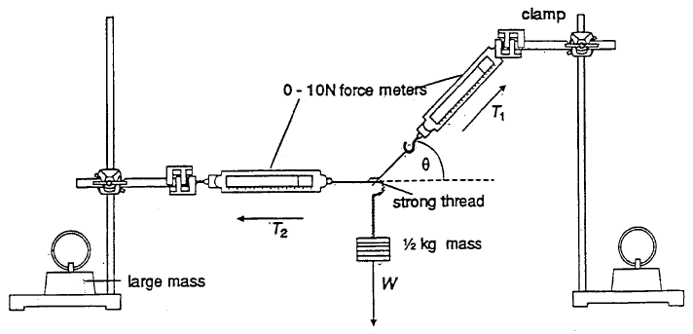
Safety
Consider the safety aspect of the set-up for your experiment. Make sure that you do not let any weights fall onto your feet.

- Assemble the equipment as in the diagram.

- Adjust the retort stand and the heights of the clamps until the system is balanced with the left hand force meter lying horizontally. (Decide on a suitable method for ensuring the newton meter is horizontal)

- Measure θ as accurately as possible using an angle measurer. Record θ and the values T₂, T₁ and W (remember that $W=mg$ and g is 9.81 N/kg.)

- Repeat the experiment for different values of W.
Result Analysis
T₁ /N | T₂ /N | W /N | θ /° | Horizontal Component of T₁ ($T_{1}\cos{θ}$) | Vertical Component of T₁ ($T_{1}\sin{θ}$)

- According to theory:
Total force acting to the left = T₂ Total force acting to the right = $T_{1}\cos{θ}$
From your results, how do these forces compare?

- In this experiment:
Total downward force = W Total upward force = $T_{1}\sin{θ}$
From your results, how do these forces compare?

- What conclusions can you make horizontal and vertical force acting on a system in equilibrium?

- Plot a graph of weight on the y-axis against T₁ on the x-axis. Show that the gradient of your graph is equal to sin θ.

- For any system in equilibrium, the total resultant force should be zero. For one of your results, draw an accurate vector diagram, adding the forces head-to-tail. You should find that you obtain a closed triangle, indicating that the resultant is zero.

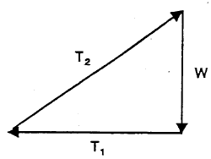  T₁ /N | $T_{2}\cos{θ}$/N | $W\sin{θ}$/N | $T_{2}\cos{θ}+W\sin{θ}$/N

- Try taking components along the direction defined by T₁. You should find that:
Total force in direction of T₁=Total force in opposite direction
$$T_{1}=T_{2}\cos{θ}+W\sin{θ}$$
Check that this works for some of your results

