Investigating factors affecting Circular motion
- Method: Aim to swing the bung around your head keeping it in a horizontal plane.
- Copy the diagram
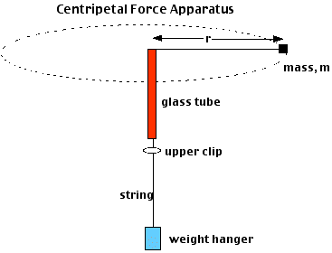
- Copy the table :
Force  (N) | Mass  (kg) | T₂₀ (s) |  | T_{ave}  (s) | r (m) | dist=C=2π r  (m) | V = d/T  (m/s) | V² _{(m}²_{/s}²₎

- Now do the experiment to fill columns 1,2,3,5
- Complete and calculate values for the remaining columns.
- Plot 2 graphs for HW. Of Force versus Velocity AND Force versus Velocity squared.
- Try to explain what the two graphs show?

- Now consider how to investigate a change in mass.
Plan how you would need to carry this factor out. Think of your Independent variable. Your Dependent variable, and your control variables.
How can you minimize errors?
______________________________________________________________________________________________________________________________________________________________________________________________________________________________________________________________________________________________________________________________________________________________________________________________________________________________________________________________________________________________________________________________________________________________________________________________________________________________________________________________________________________________
Force  (N) | Mass  (kg) | T₂₀ (s) |  | T_{ave}  (s) | r (m) | dist=C=2π r  (m) | V = d/T  (m/s) | V² _{(m}²_{/s}²₎
Now plot a graph of _________________ versus _____________________ to look for a pattern.

