Investigating the bridge crane
Aims
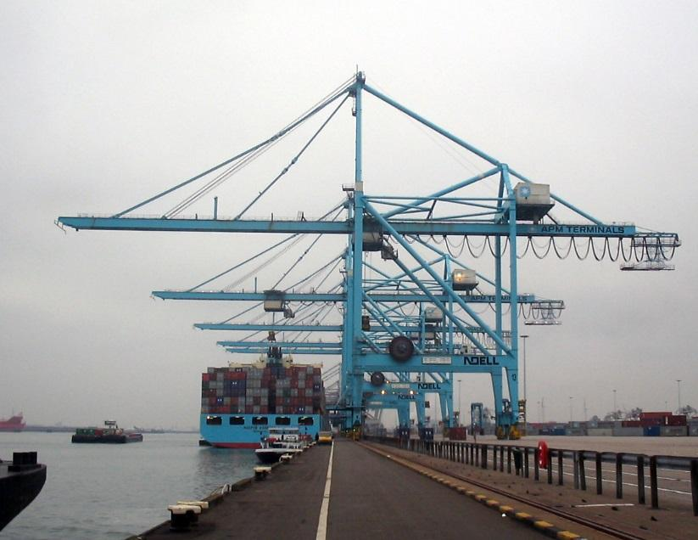
In container ports, a bridge crane is used to load and unload containers onto ships. When, for example, it moves a container from a ship onto a rail wagon, the force changes on each pillar. In this investigation, a model of the bridge crane is used to test how the force on each pillar varies with the position of the load.
Figure SEQ Figure \* ARABIC 1 Bridge cranes at a port in Roterdam (Credit: M. Minderhound)

Safety and risk assessment
The apparatus can be heavy and potentially unstable. Describe how you could ensure that they will not topple over, and how it will supported securely.

Equipment, materials and method
- For this experiment you will need: two metre rulers; two spring balances calibrated in newtons; a set square; slotted masses of weight that can be measured using either balance; thread; two stands and clamps.
- Make a model of the bridge crane, as shown in Figure 2, using two spring balances, a uniform bar and a suitable known weight W. Check that the bar is horizontal, then measure the distance D between the points of support of the bar.
- Suspend weight W from the bar, adjusting the spring balances to keep the bar horizontal and the balances vertical. Measure and record the reading on each spring balance (S₁ and S₂), together with the distances d₁ and d₂ from W to where each spring balance supports the bar. (See Figure 2.) Repeat these measurements for several different positions of the weight along the bar. Record all your measurements in a suitable table.

Theory
Taking moment about the point where spring balance S₂ supports the bar gives:
$S_{1}D=Wd_{2}+\frac{1}{2}W_{0}D$
Therefore:
$S_{1}=\frac{W}{D}d_{2}+\frac{1}{2}W_{0}$
A graph of S₁ on the vertical axis (y-axis) against d₂ on the horizontal axis (x-axis) should therefore be straight line with a gradient $\frac{W}{D}$ and a y-intercept equal to $\frac{1}{2}W_{0}$.
Use the equation of a straight line, below, to make sure you understand why this is the case.
$y=mx+c$
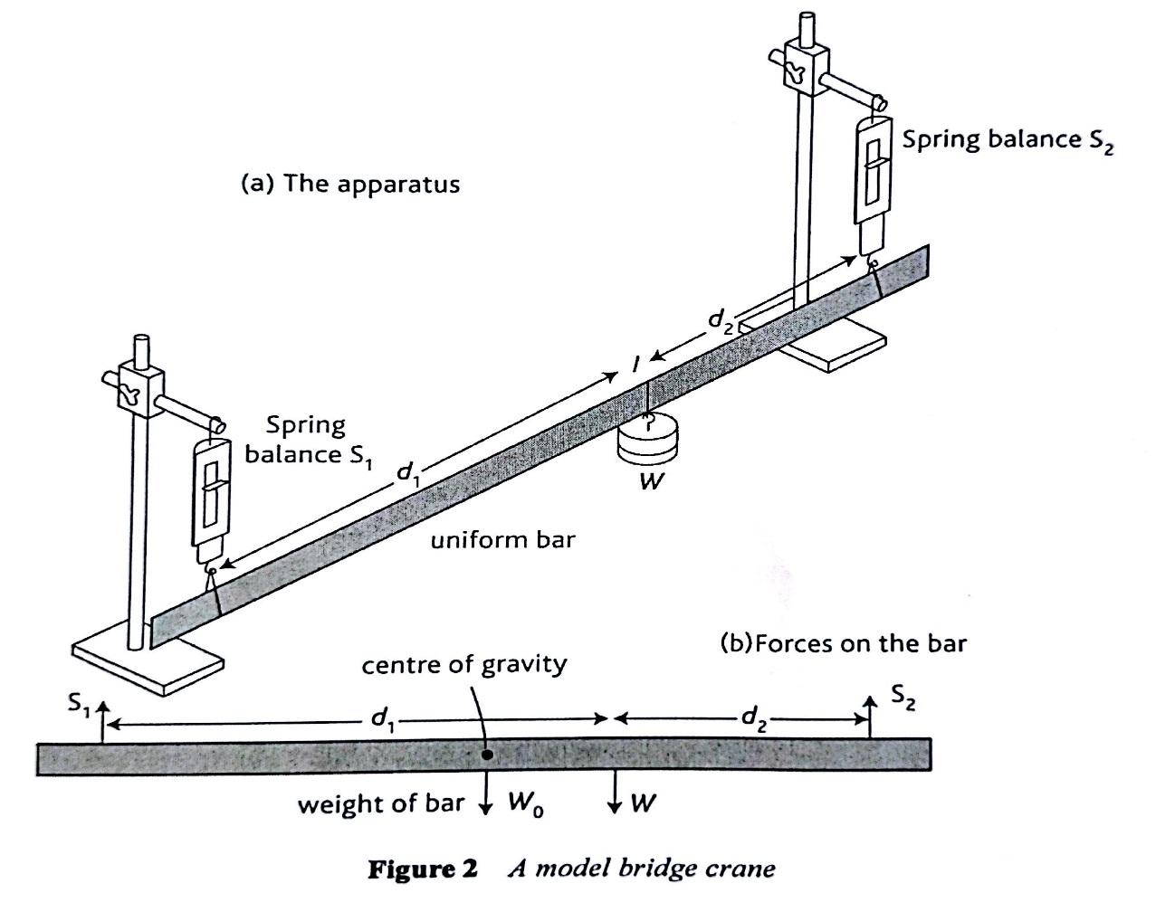

Results
Plot a graph of S1 against D2 to confirm the theory and use the graph to determine the weight W and the weight of the bar W₀.
On your graph draw a worst line of fit to estimate the uncertainty in W₀.
Questions
- a. Explain how you checked that the metre ruler was horizontal.
  - Explain in terms of forces, and vector why it was important for the ruler to be horizontal and the spring balances to be vertical.
- a. What is the most significant source of error in this experiment?
  - Discuss how you could reduce the most significant source of error.
- Calculate the absolute uncertainty (Δ) in both the smallest and largest values of S₁.
- A student who carried out this investigation forgot to check the spring balances for zero errors.
  - What is meant by a zero error?
  - What would be the effect on the graph of a zero error in one of the spring balances?

