Measuring the SHC of a fluid using a continuous flow method

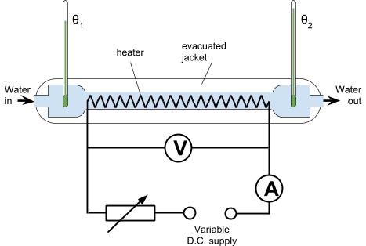

This method, was developed to avoid many of the problems inherent in the simple laboratory method that you have already used. The two biggest drawbacks of the simple laboratory method are that as the material being tested gets hotter, more the rate of heat transfer to the room increases. Even with careful lagging, there will be a reasonable amount of heat lost as the apparatus, the lagging, and even the thermometers, are never allowed to come to constant temperature. The second is that to calculate an accurate value for specific heat capacity, all the heat capacities for all of the parts of the apparatus must be accounted for, which makes the calculations hard to perform.

The continuous flow method uses a fluid (liquid or gas), which flows through a tube, in which there is an electric heating element. The rise in temperature of the fluid is measured (𝛳₂-𝛳₁), as is the rate of flow of the fluid mass through the tube (m). By using two different flow rates and adjusting the power of the heater to give the same temperature rise, the specific heat capacity of the fluid can be determined, and heat losses to the surroundings eliminated. This method allows a small temperature rises to be used, which reduces the rate of heat transfer to the surroundings. It also allows the apparatus to come to a steady state so its heat capacity can be ignored.

Using significantly different flow rates (such as f and 2f) the percentage error can be largely reduced.

Eliminating the effect of heat energy lost to the surroundings

Continuous flow method for specific heat capacity of a fluid
Electrical energy supplied in time t = energy transferred to the fluid + energy lost to surroundings

$$IVt=mc(θ_{2}-θ_{1})+Q$$

Where:
- I is the current in A
- V is the potential difference across the heater in V
- t is the time in s for a mass m in kg to flow through the apparatus.
- c are the initial and final temperatures of the fluid in °C
- Q is the heat lost to the room in J
- c is the specific heat capacity of the fluid in J kg⁻¹ °C⁻¹

When the flow rate is changed to m₂, then I and V are adjusted so that 𝜃₂-𝜃₁ is the same. Now:

$$I_{2}V_{2}t_{2}=m_{2}c(θ_{2}-θ_{1})+Q$$

As the temperature increase is the same for both, the heat lost to the surrounding will also be the same. It can therefore be eliminated, by subtracting the second equation from the first:

$$IVt-I_{2}V_{2}t_{2}=mc(θ_{2}-θ_{1})-m_{2}c(θ_{2}-θ_{1})$$

As c is the only unknown, it can now be calculated.

