Measuring the temperature coefficient of resistance for a metal wire.

Background
Metal conductors contain a sea of free electrons amongst the ionic cores of the metal atoms. It is these sea electrons which carry the electric current. All particles vibrate due to the emission of radiation (heat energy) the more radiation they emit the more they vibrate. This means that as a conductor is heated the electrons will be more obstructed in their path due to the increased vibrations and the resistance of the conductor increases.

Aim
In this practical you will heat a wire in a water bath and observe how the current (I) flowing through the wire and the potential difference (V) across it change as the temperature (T) of the wire changes.
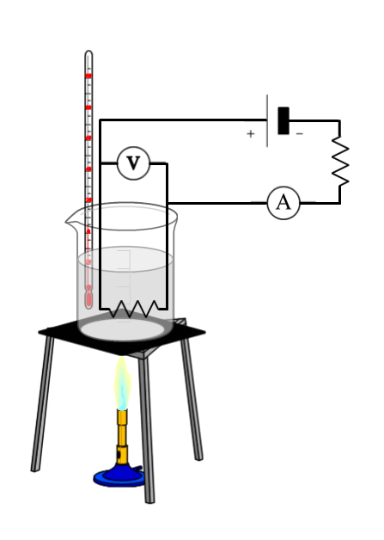

Equipment
- Test wire coiled around a glass rod
- Thermometer
- Ammeter/multimeter
- Voltmeter/multimeter
- Power supply
- Resistor
- Wires
- Bunsen burner
- Tripod and gauze
- Beaker
- Heat-proof mat
- Clamp stand
- Ice

Method
- Collect the equipment.
- Carefully set up the heating equipment as in the diagram. Do not fill the beaker yet or start heating.
- Set up the circuit as in the circuit diagram. The resistor in the beaker is the test wire, the other resistor is used to make sure that there is not a short circuit which could damage the power supply.
- Select a value of resistance that gives measurable changes in I and V as the temperature changes. (hold the wire in a clenched fist for a minute and observe any changes in I and V, the changes may be on the scale of tenths of a milliamp.
- Fill the beaker with ice and water. You need enough ice to bring the water to its triple point (0 ℃)
- Place the test wire in the beaker on top of the tripod. Use the clamp stand to ensure that the apparatus are stable and safe and the wires are not in danger of being melted.
- Record the values for I and V at 0 ℃ in a table such as the one below:

Temperature /℃ | Current /A | Potential Difference /V | Resistance /Ω

- Begin heating the water and record the values of I and V every 10 ℃ until the water boils at 100 ℃.

Results analysis
- For each pair of readings of I and V calculate the resistance (R)
- Plot a graph of R on the y-axis against T on the x-axis
- Find the gradient of the line with a suitable gradient triangle. Calculate the temperature coefficient of resistance (α) for your test wire.

$α=\frac{Gradient}{Resistance at 0 ℃}$

Questions
- Why was such a long piece of wire needed for the experiment?
- Why could you not use standard laboratory ammeters or voltmeters?
- Water boils at 100 ℃, this is described as a fixed temperature point. What was the other fixed temperature point that you used?
- Describe any risk assessment issues that you had to consider during your practical work.
- Compare your results for α with others in the class and comment on the similarities or differences.
- Describe your graph in terms of the equation for a straight line, $y=mx+c$
- Calculate the resistance of the wire at:
  - 65 ℃
  - 170 ℃
  - -40 ℃
  - 2000 ℃
- Comment of the validity of the last calculation.

