Measuring the IV Characteristics of some common components
Task – You are to take measurements of current through and potential difference across four common components to produce a graph of its IV characteristic.
You will test the components shown below with their symbols and a brief description. At the end of the practical you should add a description for the Diode and the Thermistor.
Resistor | 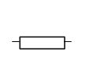 | A resistor has a constant resistance as long as its temperature is constant. It obeys Ohm’s law and is said to be ohmic.
Filament bulb | 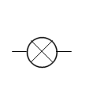 | A filament bulb produces light when electrons flow through a high resistance wire and transfer a lot of energy as heat.
Diode | 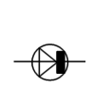
Thermistor | 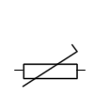

For each of the components follow these steps and suggestions
- Set up the circuit shown on the board. You may want to copy the circuit diagram into your notes.
- Set the power supply to deliver either 3V or 4.5V and select a value of resistor to test.
- Record the precision of the ammeter and the voltmeter.
- Make some initial tests to help you decide the values of pd to use, given that the variation of current with pd may not be linear. Pay particular attention to the range of pds for which the current changes significantly.
- Draw a table to record your results, include all necessary headings and units.
- Measure the current through the component for each pd you have chosen. Take sufficient readings so that repeat readings are not necessary.
- Reverse the battery connections and repeat the experiment.
- Draw a graph of current (y axis) against potential difference (x axis).
Questions on Measuring IV Characteristics
Answer these questions for each component
- What is the percentage uncertainty for,
  - The 3rd reading for pd and current for each component?
  - The largest value for pd and current for each component?

- What does the gradient of the graph show?
$$y=mx+c$$
Rearrange $R=\frac{V}{I}$ to fit the equation for a straight line.

- Describe how the resistance of the components changes as the pd is increased.

- Calculate the resistance for the values you used above.

- Use the answers to questions 1 and 4 to find the percentage uncertainty and the absolute uncertainty of the two values for resistance.

