Current, resistance and power.
Understanding uncertainty in practical physics

When making measurements during experimental work it is important to understand that no measurement can be a perfect reading of any physical quantity. There will always be some level of uncertainty attached to any measurement. Obviously the better your measurements and your measuring equipment the less uncertainty there will be attached to any reading.
When stating a measurement the uncertainty should be stated alongside it. This makes it possible to comment on the accuracy of your readings and calculated data.
During this practical you will take a series of measurements and calculate the uncertainty of both recorded and calculated data. You should refer to the Practical calculations and errors sheet throughout this practical.
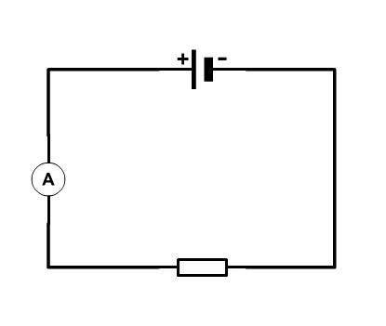
- Set up the circuit as in the diagram using a What-a-cell box. Use the resistor block that has resistors in the range of 15Ω to 68Ω. Choose a combination of resistors that produces the smallest value of resistance that you can (≈9Ω).
- Set the multimeter to read 20 V and connect it across the resistance to measure the voltage across it. Record this in the table.
- Record the resolution of the measuring device. Estimate the absolute uncertainty and the percentage uncertainty in this measurement.
  - Comment on how this value of percentage uncertainty would have been different if you had used either the 200 V or the 2 V setting on the multimeter. (If you use an auto-ranging you will have to use your imagination!)
- For the current value of resistance select the setting on the ammeter that would give the smallest amount of uncertainty.
- Record the value of current in the table.
- Increase the resistance and check that the multimeters are on a suitable setting. Record the current and potential difference and repeat until you have 9 readings between ≈9Ω and ≈120Ω.
  - What would be an appropriate number of readings and how would you decide?
- Find the power using the equation $P=IV$.
- Plot a graph of Power (y-axis) against Resistance (x-axis).
  - Which value of R gives the smallest % uncertainty in P?
  - When comparing uncertainties in the current is it more useful to use the Δ or ε?

- Extension: If you have time repeat the practical using a power supply set at 3V and plot the same graph. Comment on the differences.

Resistance /Ω | Current /A | Absolute uncertainty (Δ) | % uncertainty in Current (ε) | Potential difference /V | Absolute uncertainty (Δ) | % uncertainty in p.d. (ε) | Power /W | % uncertainty in Power (ε)

