Testing the equation $v^{2}=u^{2}+2as$

In this experiment you will find the velocity of a trolley after it has travelled different distances down an inclined runway. The velocity is found using a computer and a light gate to measure how long a card of known length takes to pass a certain point. The computer can then calculate the velocity to a high resolution.

You will use the Neulog software to measure the speed. You will then plot a graph to test the validity of $v^{2}=u^{2}+2as$.

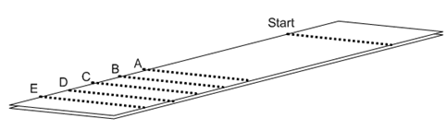

Method

- Assemble the ramp and clamp stands so that the ramp is inclined at an angle of no more than 20°. Collect a trolley and a single interrupt card. You should already have a light gate and USB module by your laptop.
- Using a pencil, clearly mark a start line at the top of the runway from which you will release the trolley on each run.
- Now measure 5 distances further down the runway, at least 1m from the start, but not too close to the end of the runway. Mark them A to E.
- Position the light gate over the line marked as A, and then align the centre of the interrupt card on the trolley with the start line. Ensure that the trolley will run through the light gate.
- Run the experiment on the laptop, then release the trolley making sure that it is caught before it drops onto the floor. Record the velocity in the table below.
- Repeat the experiment twice more with the light gate at A and then move the light gate over line B and repeat the experiment.
- Continue until you have recorded velocities for each line.

Distance in metres from the start to: | Velocity / ms⁻¹ |  |  |  | Velocity squared / m²s⁻²
Distance in metres from the start to: | 1 | 2 | 3 | mean | Velocity squared / m²s⁻²
A =
B =
C =
D =
E =

- Calculate the mean velocity for each row and then velocity squared.
- The equation that links velocity and displacement under a constant acceleration is:
$$v^{2}=u^{2}+2as$$

- But for this example, the initial velocity is zero, so the equation simplifies to:
$$v^{2}=2as$$

- This equation can be verified by plotting a graph of velocity squared against displacement. The gradient of the graph should be $2a$.
- You should plot error bars on your graph for each value of velocity squared. These can be used to help guide your line of best fit as well as your worst line of fit.
- Use your gradient to find the acceleration down the runway and estimate the percentage uncertainty.

a = ___________________ ms⁻² ± _____________%

