Using a potential divider as a voltmeter
Circuit diagram
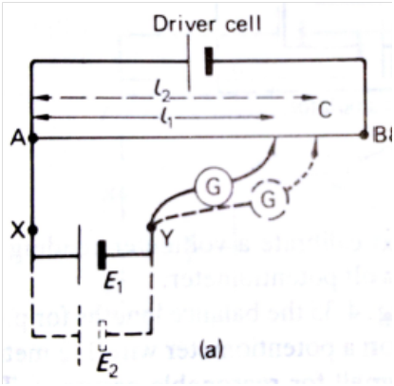
Diagram taken from Physics by Tom Duncan

The task
Using the information given on this sheet and the method provided, you need to carry out the experiment and write it up fully including a more complete explanation of the theory, and your method. You must comment on your results, their accuracy and how they can be improved.

The theory
The above potential divider circuit can be used as a voltmeter. When a power supply provides an emf to the circuit the resistance wire AB can act as a potential divider. As the wire is uniform, the potential delivered to the second circuit (ACYX) is directly proportional to the length L.
When we connect a cell or other known emf, E₁ to the second circuit between X and Y so that the current produced by the test cell opposes that of the Driver cell, no current will flow through the galvanometer when the emf of the cell equals the pd across AC.
This length L₁ can be said to represent the emf of the cell as no current is flowing and using $V_{0}=ε-Ir$ it can be seen that when no current flows the terminal voltage is equal to the emf of the cell.
The method
Using the potentiometers set up the circuit as shown and adjust the variable resistor so that the pd across the potentiometer is as close to 2.0V as you can get. Connect the cell with the known emf, E₁, to the circuit ACYX. Make sure that the galvanometer is correctly set up and is set to the least sensitive scale (if it has one) and carefully move the jockey (copper knife edge contact) along the potentiometer wire until the galvanometer reads 0. Record the length, L₁, at which no current flows.
Replace the cell of known value with the unknown cell, E₂, and repeat the procedure to find the length AC at which no current flows through the galvanometer. Record this length, L₂.

The maths
The ratio of the known, test, voltage to the unknown voltage is equal to the ratio of the length of L₁ and L₂ in each experiment.
$$\frac{E_{1}}{E_{2}}=\frac{L_{1}}{L_{2}}$$
Rearrange this to equal E₂ and you can work out the value of this unknown cell.

Uncertainties
Accuracy – Find out what the value of the unknown cell was from your teacher and calculate the percentage difference between your calculated value and the true value.
State the absolute uncertainty and calculate the percentage uncertainty for the following measurements:
- Length L₁
- Length L₂
- Known voltage E₁
Hence calculate the percentage uncertainty in your value of E₂. Does you calculated value lie within your percentage uncertainty?
Suggest ways you could improve your measurements and reduce you uncertainties.

