Verifying F=ma
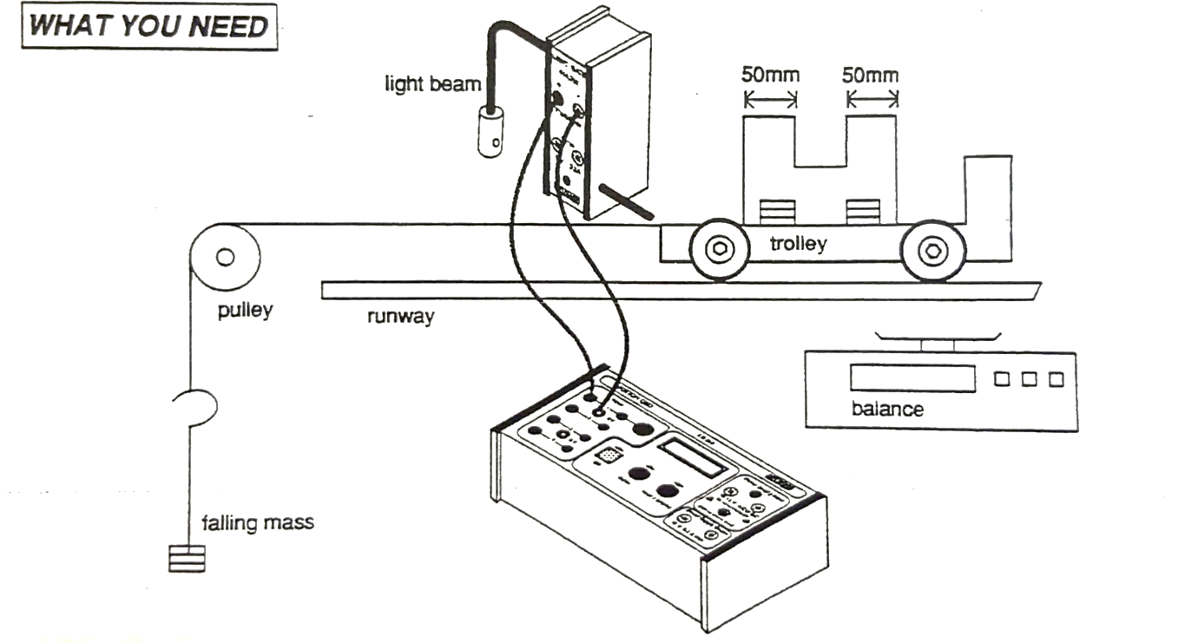
Compensating for friction
Through the bearings in the wheels, and the contact friction between the wheels and the runway, the trolley has to overcome these forces to keep moving (Newton’s 1st law). You can see that when the trolley is pushed, it comes to a stop on its own, therefore $\sum{F}≠0$.
You need to adjust the level of the runway so that the friction is compensated for. How will you check this?
Method
The falling mass will apply a resultant force on the trolley and cause it to accelerate. You need to vary the resultant force and record the acceleration of the trolley. You must ensure that the acceleration is recorded before the masses hit the ground. Set up the Neulog software to measure acceleration with one gate, and enter the width if the interrupts. Make sure you check their measurements.
It is important that the total mass of the entire moving system (trolley, masses string etc.) remains constant.
Masses and error in the masses
Although the masses are nominally 0.05 kg, there will be some variation in this. To find the uncertainty in the value for the mass, find the mass for each and calculate the uncertainty in the normal way.
Mass 1 m/kg | Mass 2 m/kg | Mass 3 m/kg | Mass 4 m/kg | Mass 5 m/kg | Mass 6 m/kg | Mass 7 m/kg | Mass 8 m/kg | Mass 9 m/kg | Mass 10 m/kg

Mean Mass m/kg | Absolute uncertainty in m (Δm) | Percentage uncertainty in m (εm)

Results
Pulling Force F/N | Acceleration a/ms⁻² |  |  |  | Absolute uncertainty in a (Δa)
Pulling Force F/N | 1 | 2 | 3 | Mean | Absolute uncertainty in a (Δa)

Total mass of system | kg

Analysing your data
Consider the equation, $F=ma$ in terms of the equation of a straight line and decide what to plot on your graph. What will your gradient represent?
You have calculated uncertainty for the masses and the acceleration. You should use these to plot error bars on your graph. These error bars will help you plot the lines of best fit for this analysis.
Plot the line of best fit on you graph and find its gradient. Estimate the percentage uncertainty in the gradient by plotting a worst line of fit.

Conclusions
Compare your gradient, considering the uncertainty, to the mass you recorded of the system. Do your results support Newton’s 2nd Law? Explain in detail.

