- Calculating the speed of a 'bullet'.
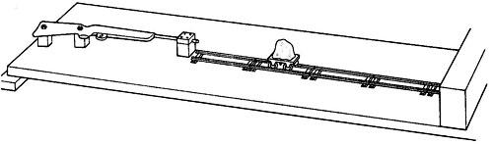
- Draw the practical situation from above and label the bodies involved in the momentum problem.

- Record the mass of the train and plasticine as well as the ball-bearing/pellet.

- Measure the width of the timing card on the carriage and enter this in to the Neulog software.

- Ensure that the track is in line with the barrel of the gun and parallel to the path of the bullet.

- Carefully load the gun (ask for help if you are not sure how to do this). Make sure that you are wearing goggles and the safety screen is in place

- Start the software and fire the gun. Record the speed of the carriage. Carry out repeat measurements, making sure that you record the mass of the carriage each time.

- These measurements should allow you to estimate the firing velocity of the pellet if linear momentum has been conserved.

- Write down a formula to represent the collision of the pellet into the truck so that the collision is sticky and then use your observed measurements to estimate the pellet impact velocity.

- You can add masses to the trolley and see what effect that has on its momentum if time allows.

Questions

- Describe all the necessary safety considerations and risk assessments you carried out for this practical.
- How could you reduce the uncertainty in your measurement of the mass of the bullet?
- Why was it important to record the speed of the carriage very soon after the collision?
- What effect would the rail not being parallel to the path of the bullet had on the result?
- Discuss how a heavier trolley might have affected the reliability of your results.

- Momentum conservation and changes of mass.
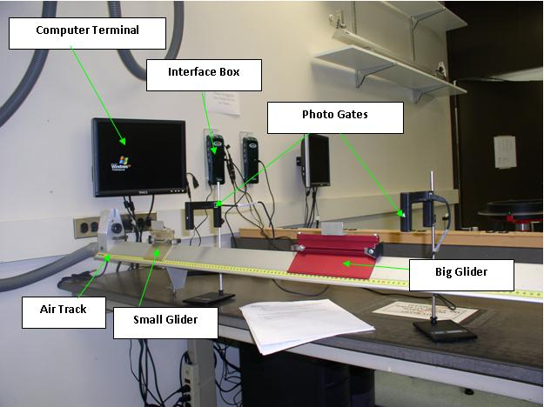

This practical will allow you to investigate the momentum before and after a collision. Using the air track you need to make careful observations of the velocity of gliders before and after collisions. You can use Neulog software connected to a computer.

- Using two gliders set one off and record its velocity. Allow it to collide with one other glider making sure that the two gliders stick together. The velocity after the collision must also be recorded.
- Alter the mass of the glider by adding masses to one of the gliders.
- Vary the velocity of the first glider and note the results.
- Record the mass of the two gliders and calculate the momentum before and after each collision.

- Make sure that the gliders DO NOT stick together and repeat the above practical.

Use the high-speed camera to record at least two collisions making sure that there is a scale recorded in camera shot, either use graduations on the air track or clamp a ruler along the base of the air track. (This may require some modifications to the ruler scale / paper and marker pens).

Momentum is conserved in a collision, $m_{1}v_{1}+m_{2}v_{2}=m_{1}u_{1}+m_{2}u_{2}$

Questions
- Explain why the conservation of momentum is more clearly demonstrated on an air track than with trolleys on a ramp.
- Calculate the absolute and percentage uncertainty for the first pair of momentum measurements and use this to comment on whether your results reliably support the law of conservation of momentum.

- Conservation of momentum in explosions.
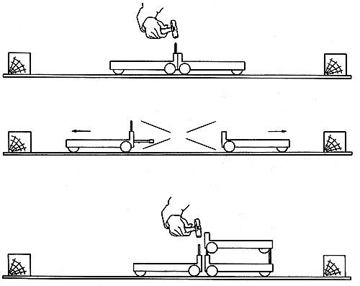

You will be investigating explosions and momentum as a vector quantity to see how both vector components are conserved. You will use your measurements of velocity to calculate the mass of an unloaded trolley.

- Set up two trolleys as above right, with the firing pin of one retracted. Use a hammer to release the firing pin or burn through an elastic band holding the two together against their own springs and record the velocity of each of the trolleys as they move away from their origin after they have finished accelerating. This can be done with light gates and Neulog software. Repeat the experiment to make sure that your results are reliable.
- Add one of the masses to one trolley (assuming the nominal value on the mass is correct) and repeat the experiment.
- Repeat for each of the masses, each time ensuring the same trolley is un-laden.
- Using the equation:
$$mv=\left(M+m\right)u$$

Where: m is the mass of an un-laden trolley
v is the velocity of one trolley
u is the velocity of the other trolley
M is the extra mass added

- Calculate the mass of an un-laden trolley

Questions

- How can you improve the reliability of you results?
- What assumptions have you made in this practical?
- In a collision, both vector components of momentum are conserved, how does this practical demonstrate this?

4. The momentum of falling sand

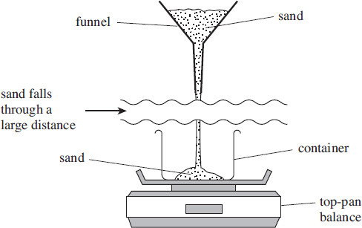

Method
- Set up funnel about 1.5m above the balance, position the container on the balance and measure accurately the height of the funnel above the balance
- Stop the end of the funnel with a finger and carefully fill the funnel with sand, control the flow of sand and take necessary measurements to calculate the rate of flow into the container in kg s⁻¹.
- Calculate the speed of the sand as it lands in the container
- Calculate the momentum per second of the sand as it lands in the container
- Calculate the force the sand applies to the balance, assuming the sand does not rebound as it lands.
- Calculate the amount of sand that would flow in 10 seconds. Measure it out carefully and pour it into the stopped funnel.
- Allow the sand to flow onto the balance. Observe the reading on the balance as the sand starts to flow and as it stops.

Questions
- Plot a sketch graph of the reading on the balance against time, explain your observations. Explain the shape of the graph and any interesting features.

